**Big Data – Case Study**

Objective: The objective of this assignment is to analyze sentiments from twitter of a highly spoken-of event that took place on 8th November 2016 in India. To combat the black money problem in the country, the government decided to demonetize two bills of the highest denominations. We will analyze on how the users reacted to the event using a dictionary and further on, we will visualize the results obtained.

Part-1:

Step-1:

Q. Take a screenshot of the terminal application and paste it below.

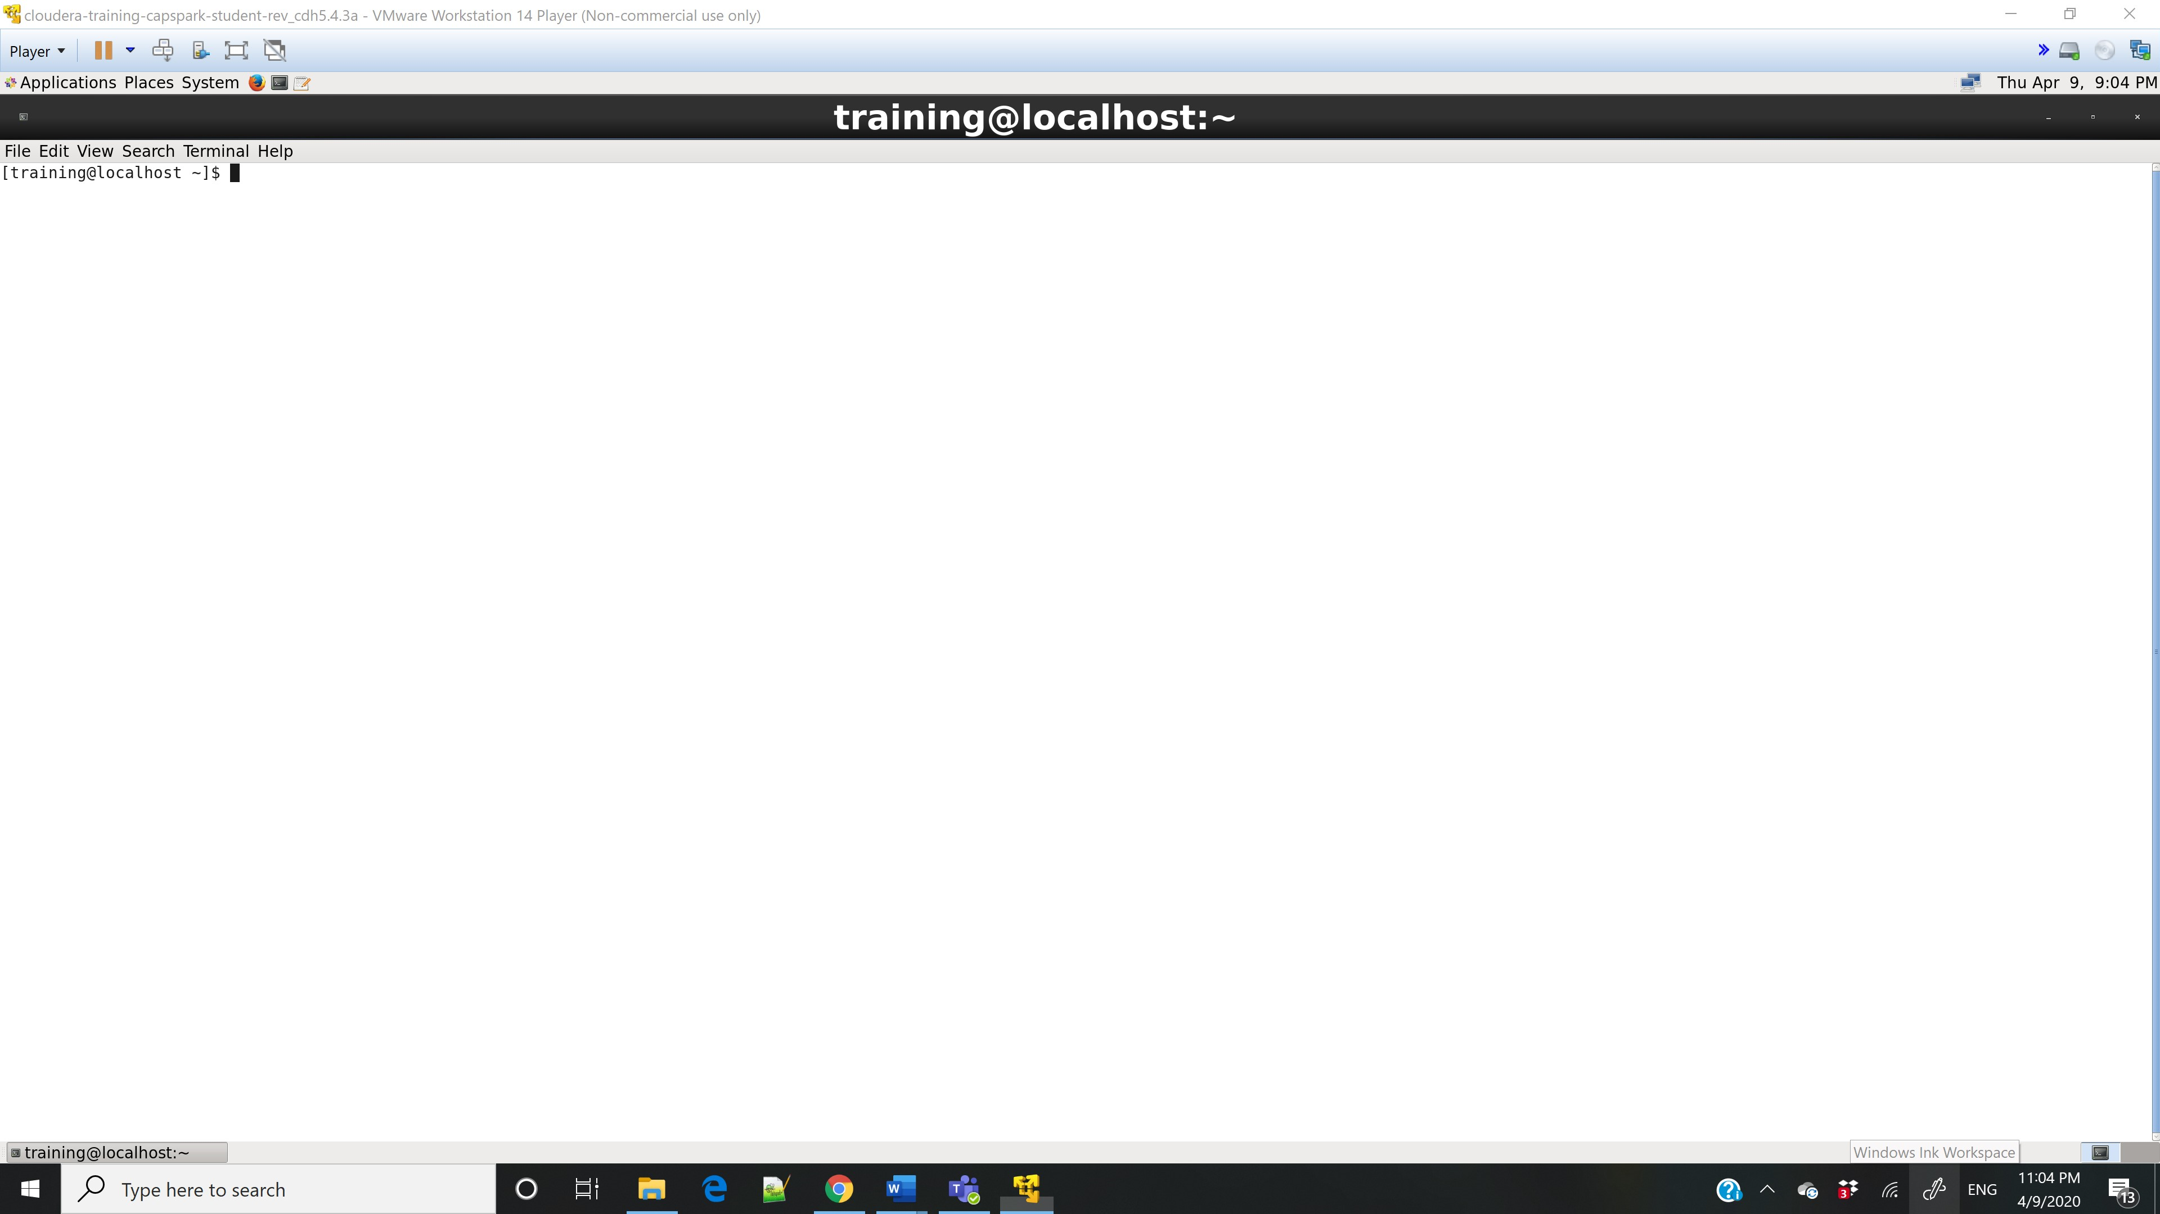

Step-2:

Step-3:



Q. Now type the command and execute. Take a screenshot of the shell output, highlight the zip file and paste it below.

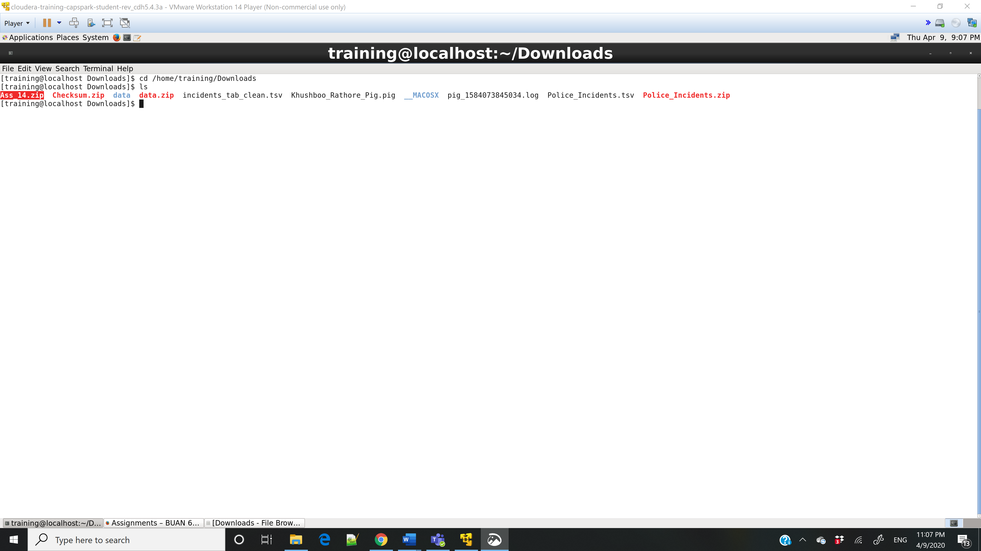

Step-4: 

Q. Now type the command and execute. Take a screenshot of the shell output, highlight the contents of the zip file and paste it below.

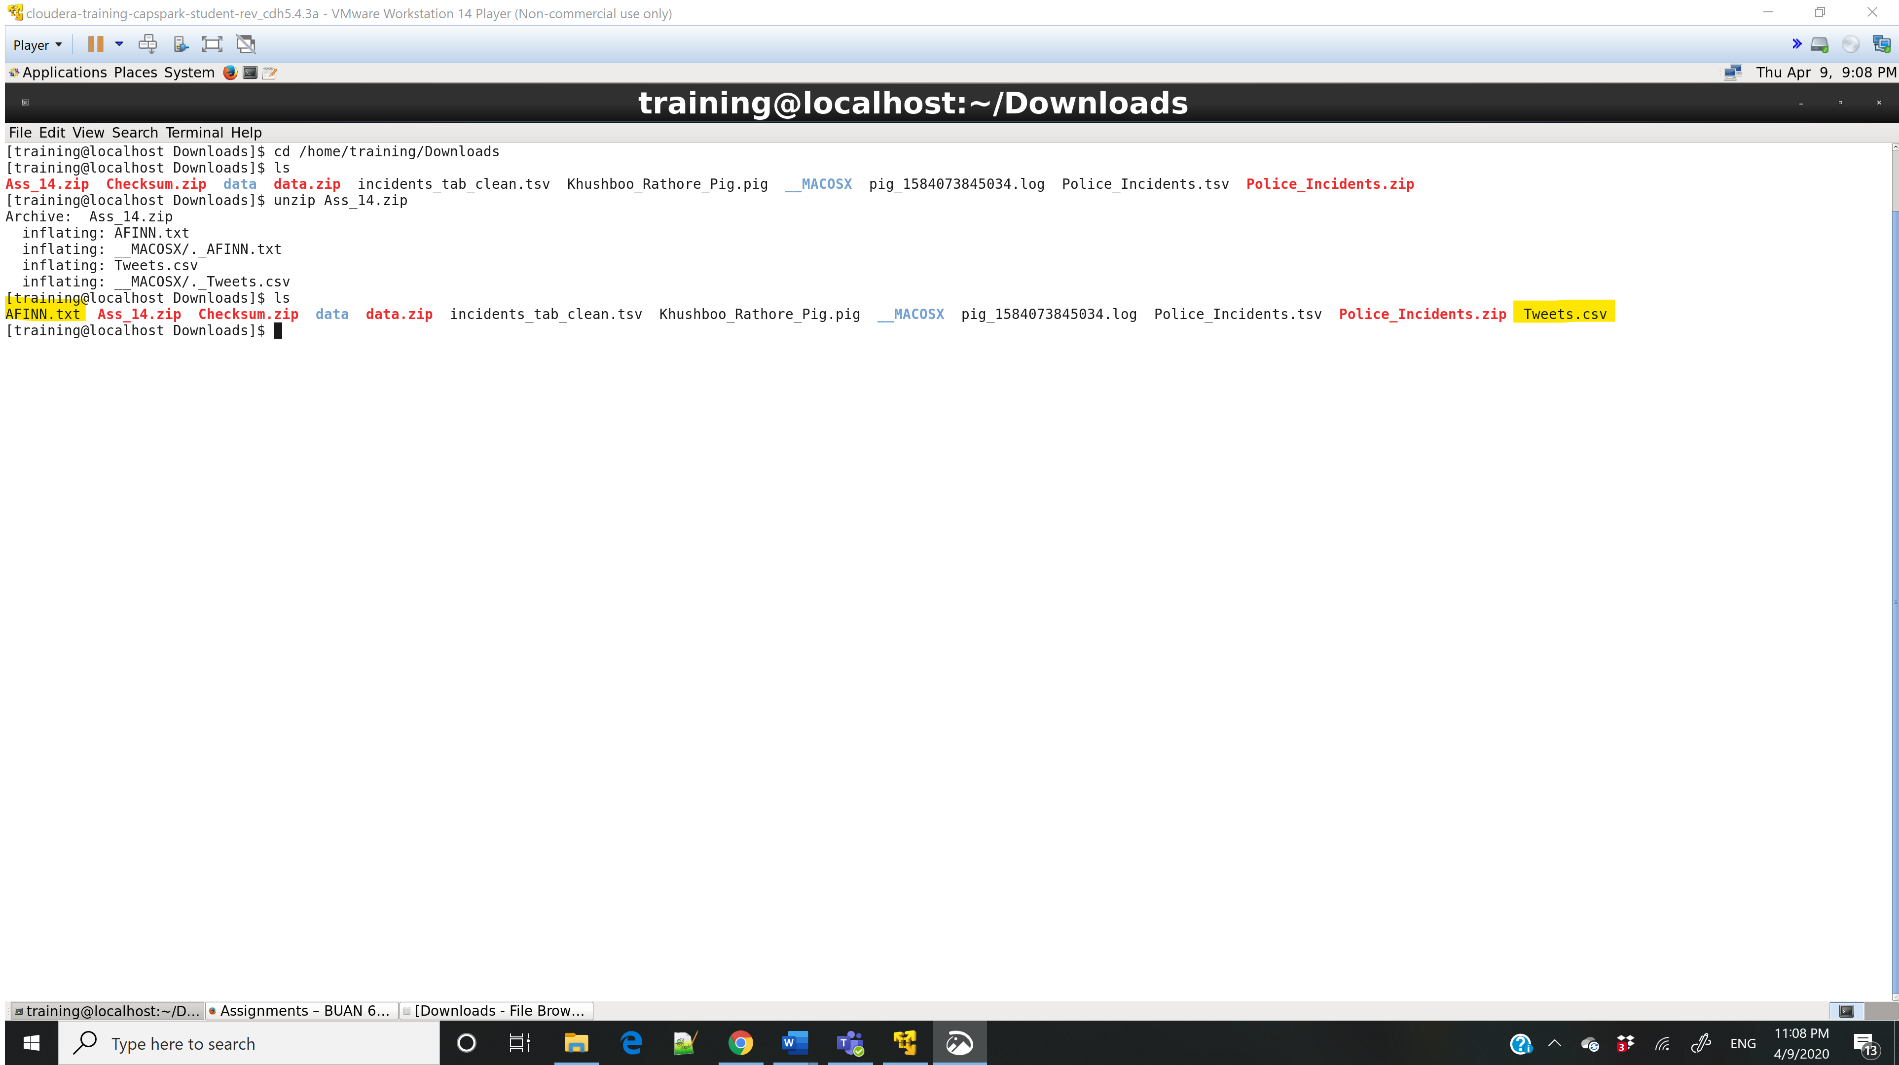

Step-5:

Q. Execute the command below and take a screenshot of the shell output and paste it below. Highlight the directory that we just created.

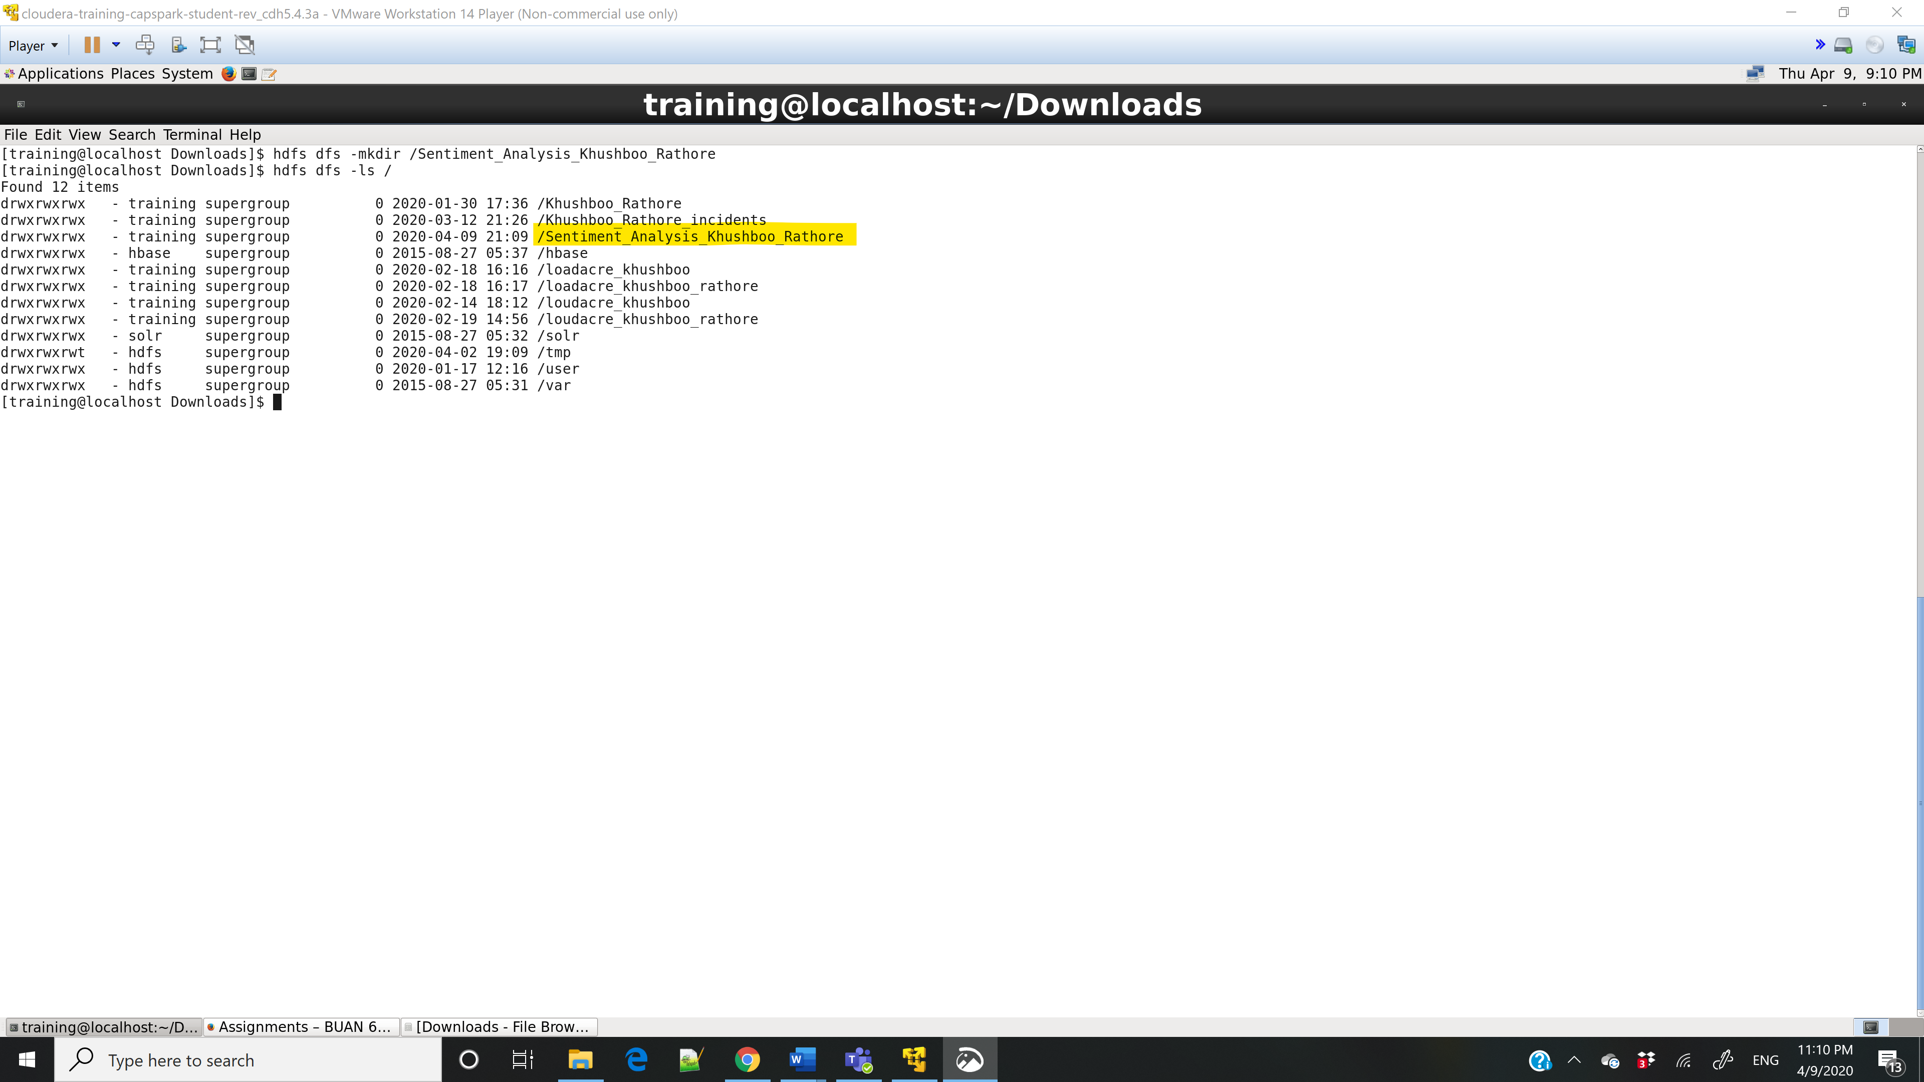

Step-6:

Q. Execute the command below and take a screenshot of the shell output and paste it below. Highlight the files we copied into HDFS.

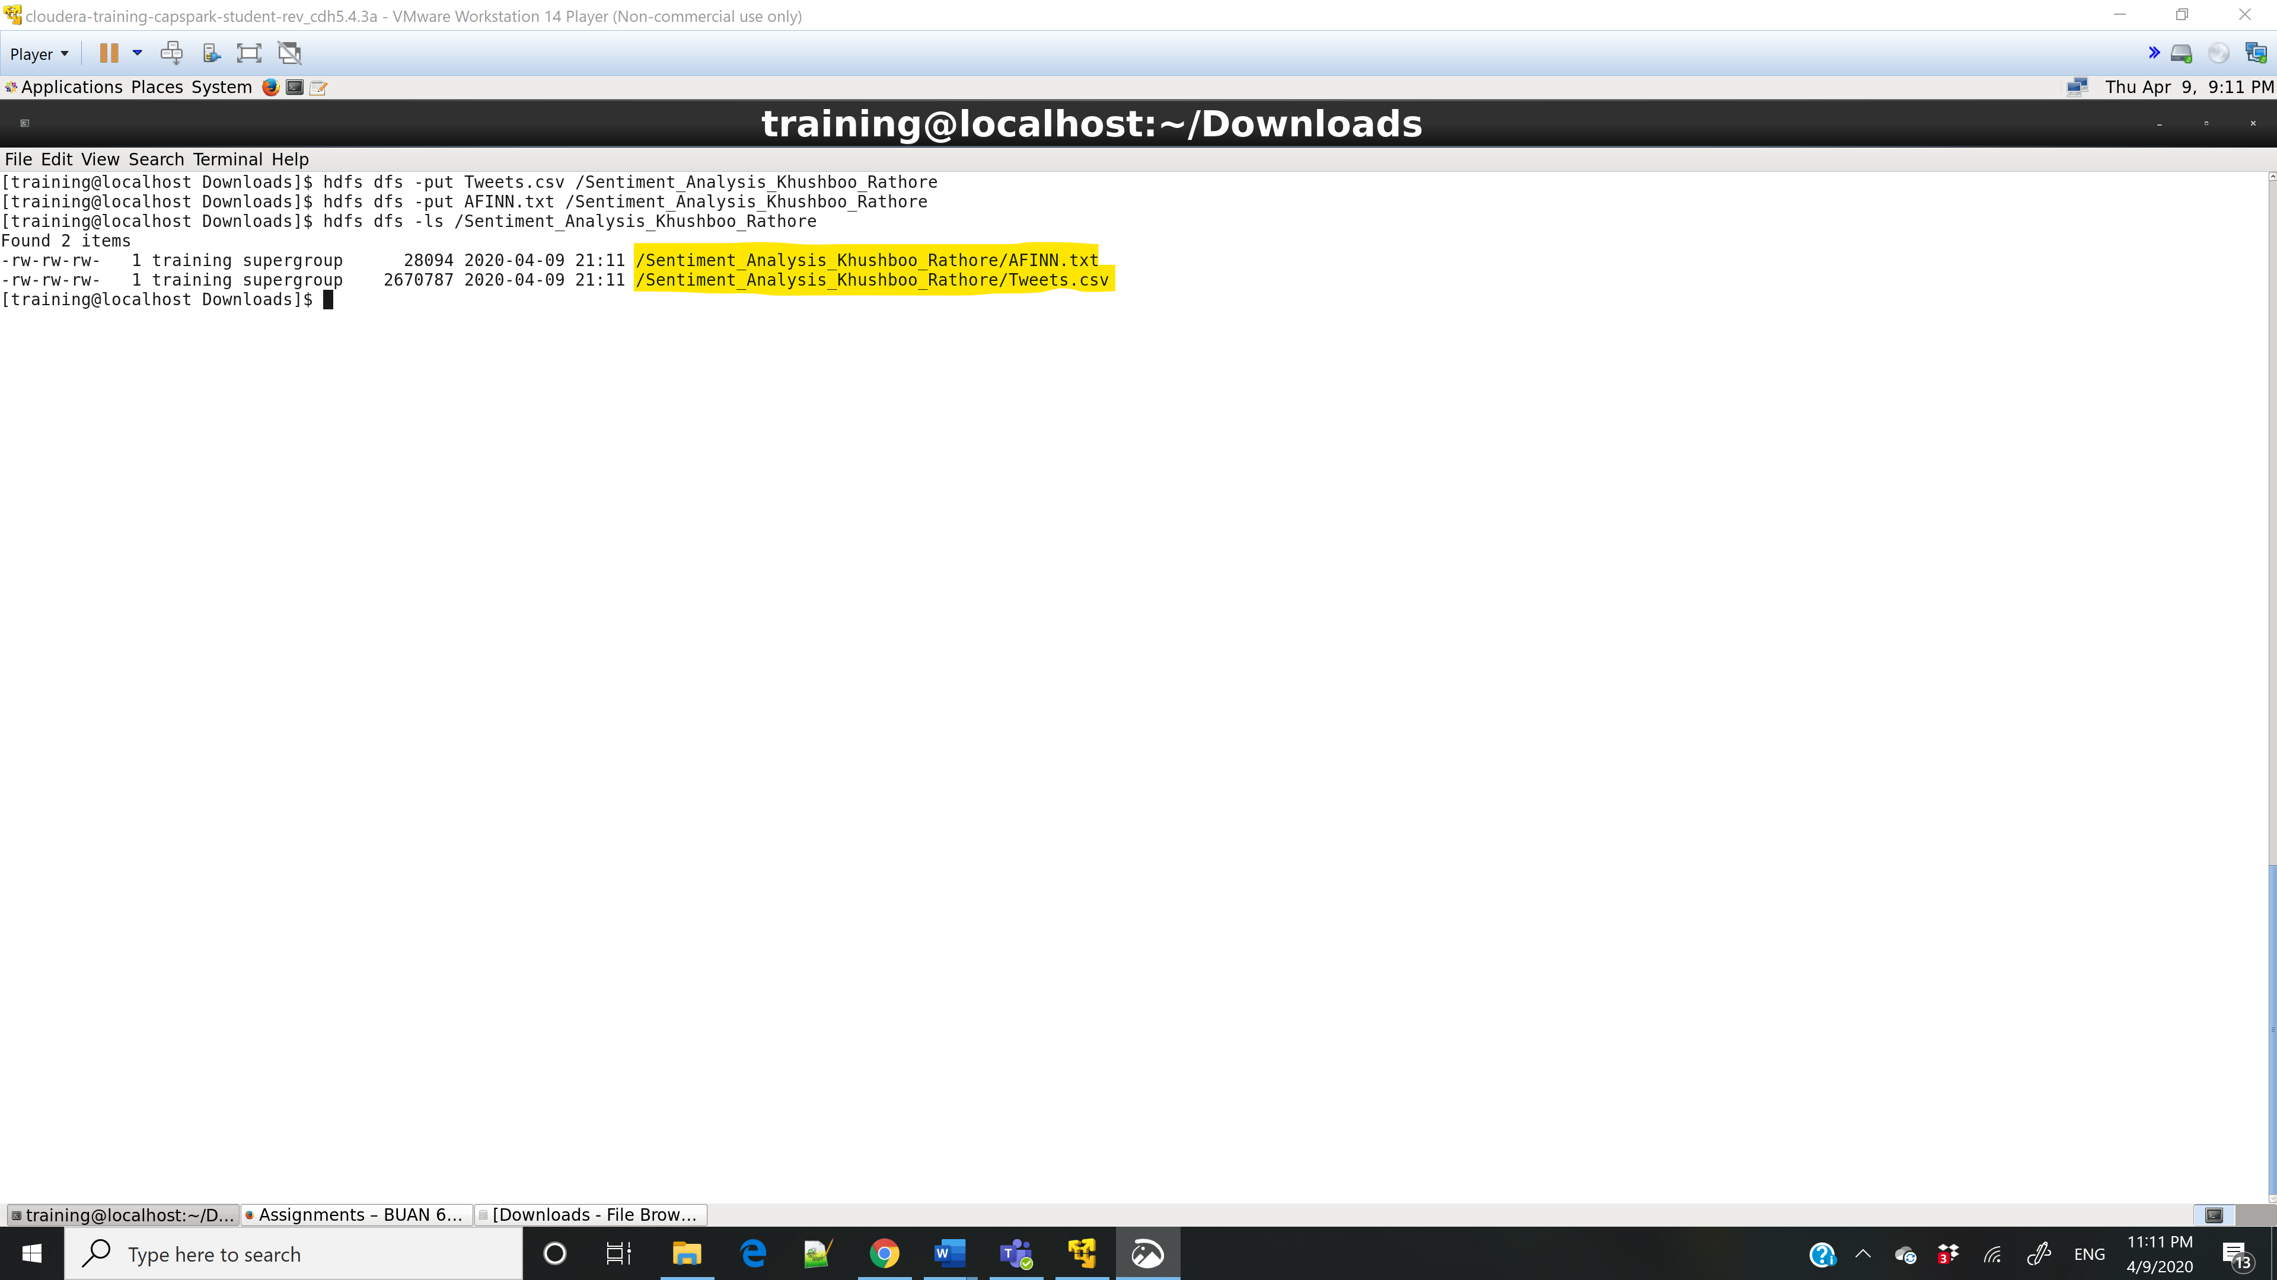

Part-2: Sentiment Analysis

Step-7:

Q. Take a screenshot of the grunt shell output and paste it below.

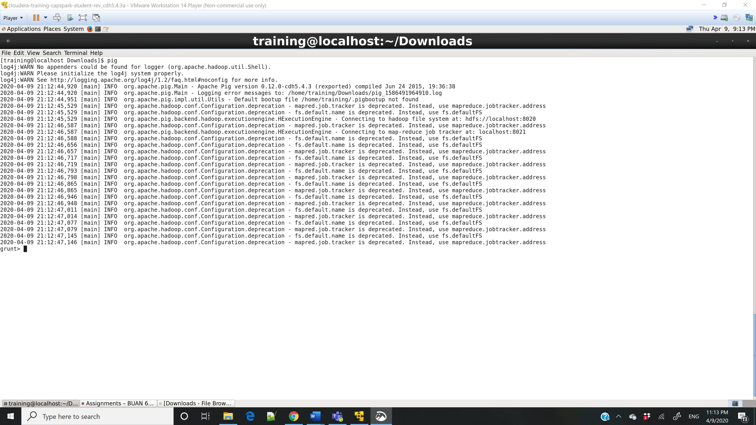

Step-8:

Q. Execute the command below, take a screenshot of the grunt shell output and paste it below.

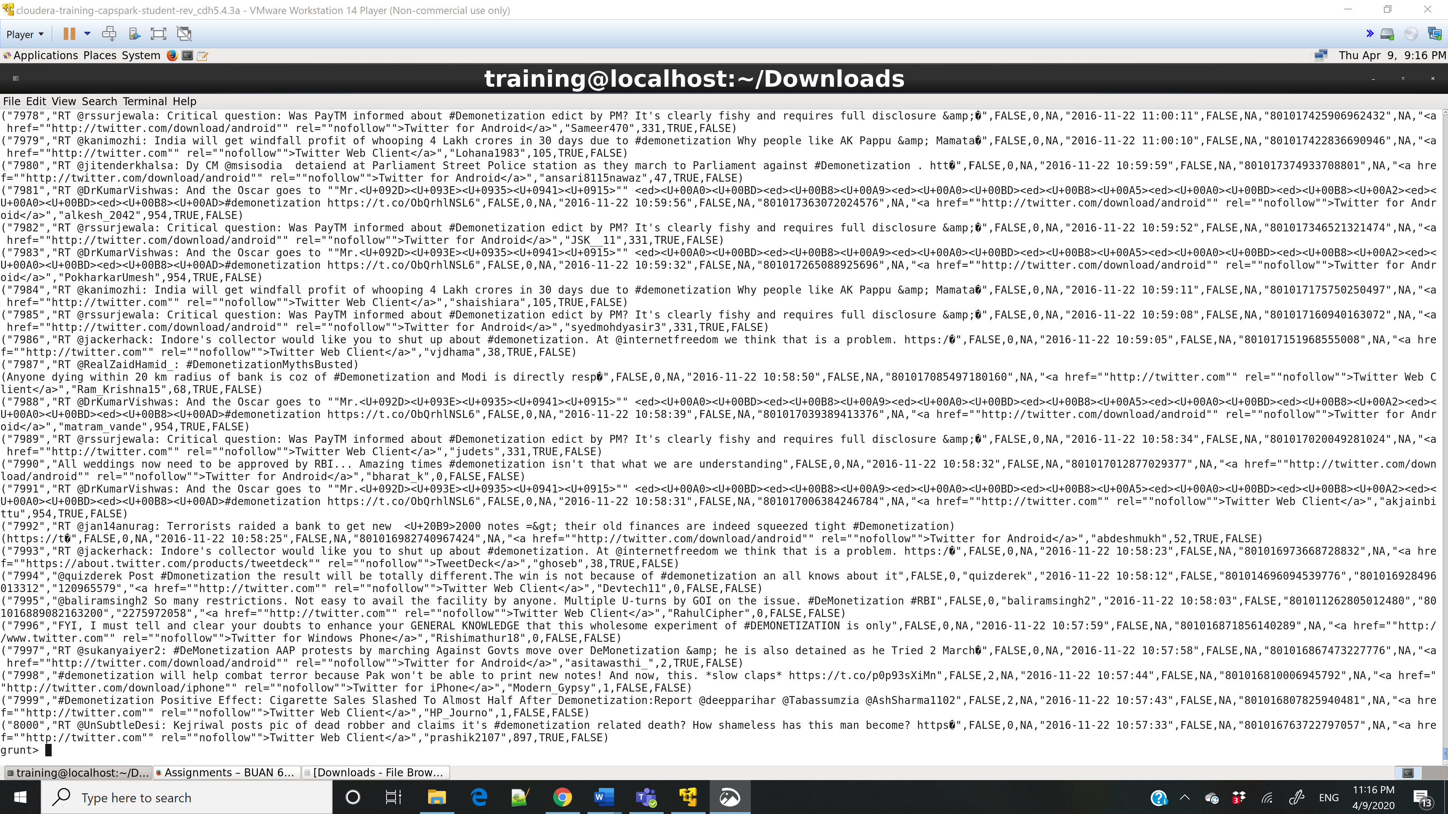

Step-9:

Q. Execute the command below, take a screenshot of the grunt shell output and paste it below.

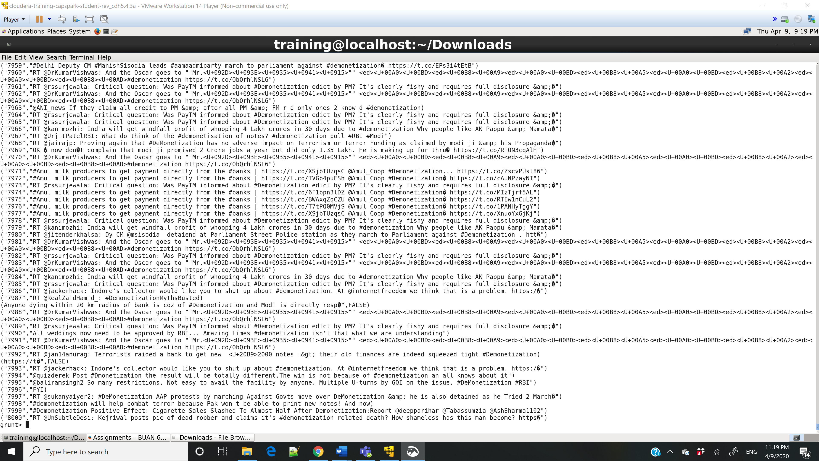

Step-10:

Q. Execute the command below, take a screenshot of the grunt shell output and paste it below.

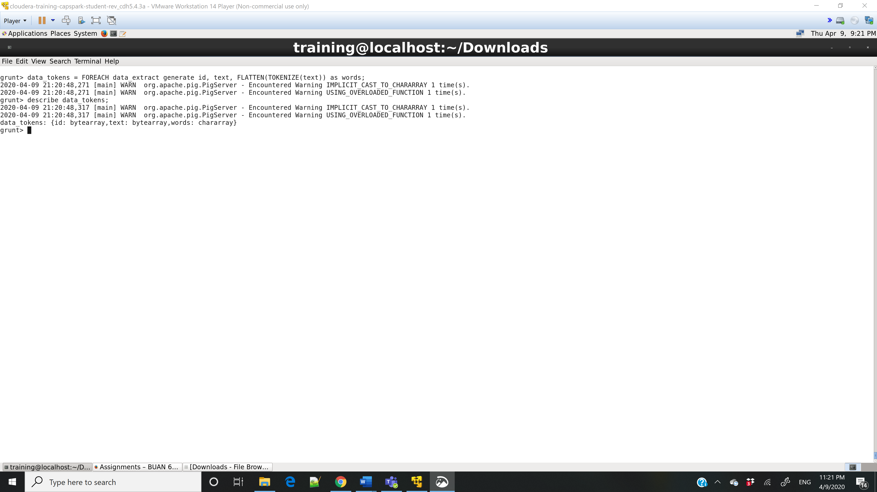

Step-11:

Q. Execute the command below, take a screenshot of the grunt shell output and paste it below.

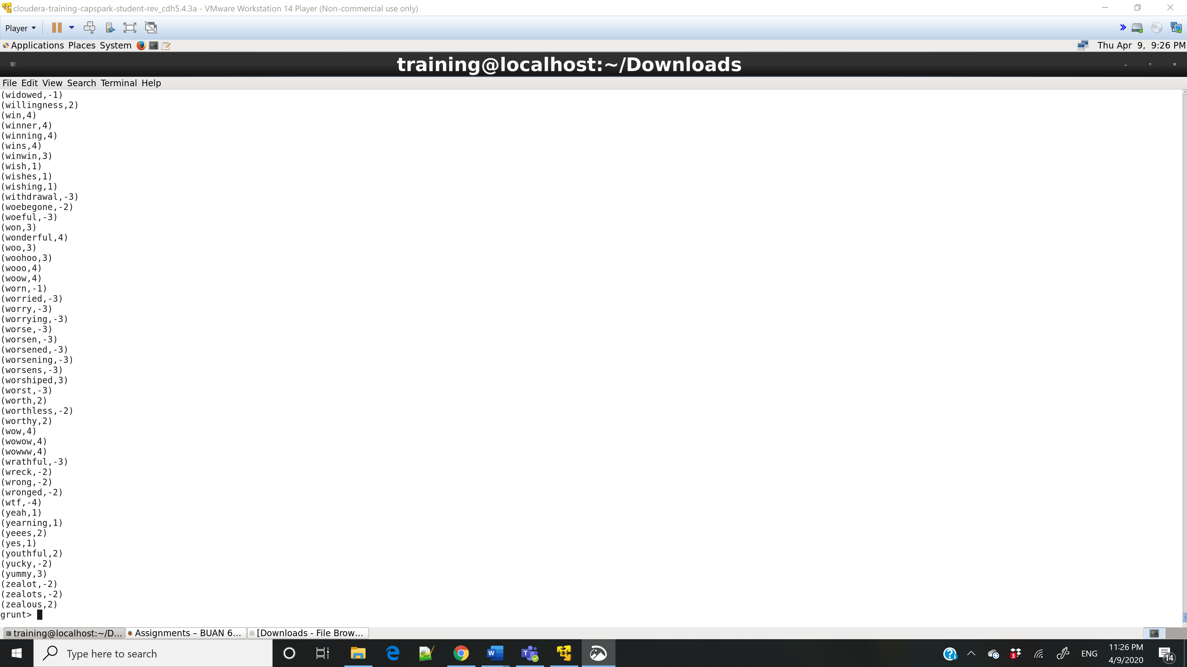

Step-12:

Q. Execute the command below, take a screenshot of the grunt shell output and paste it below.

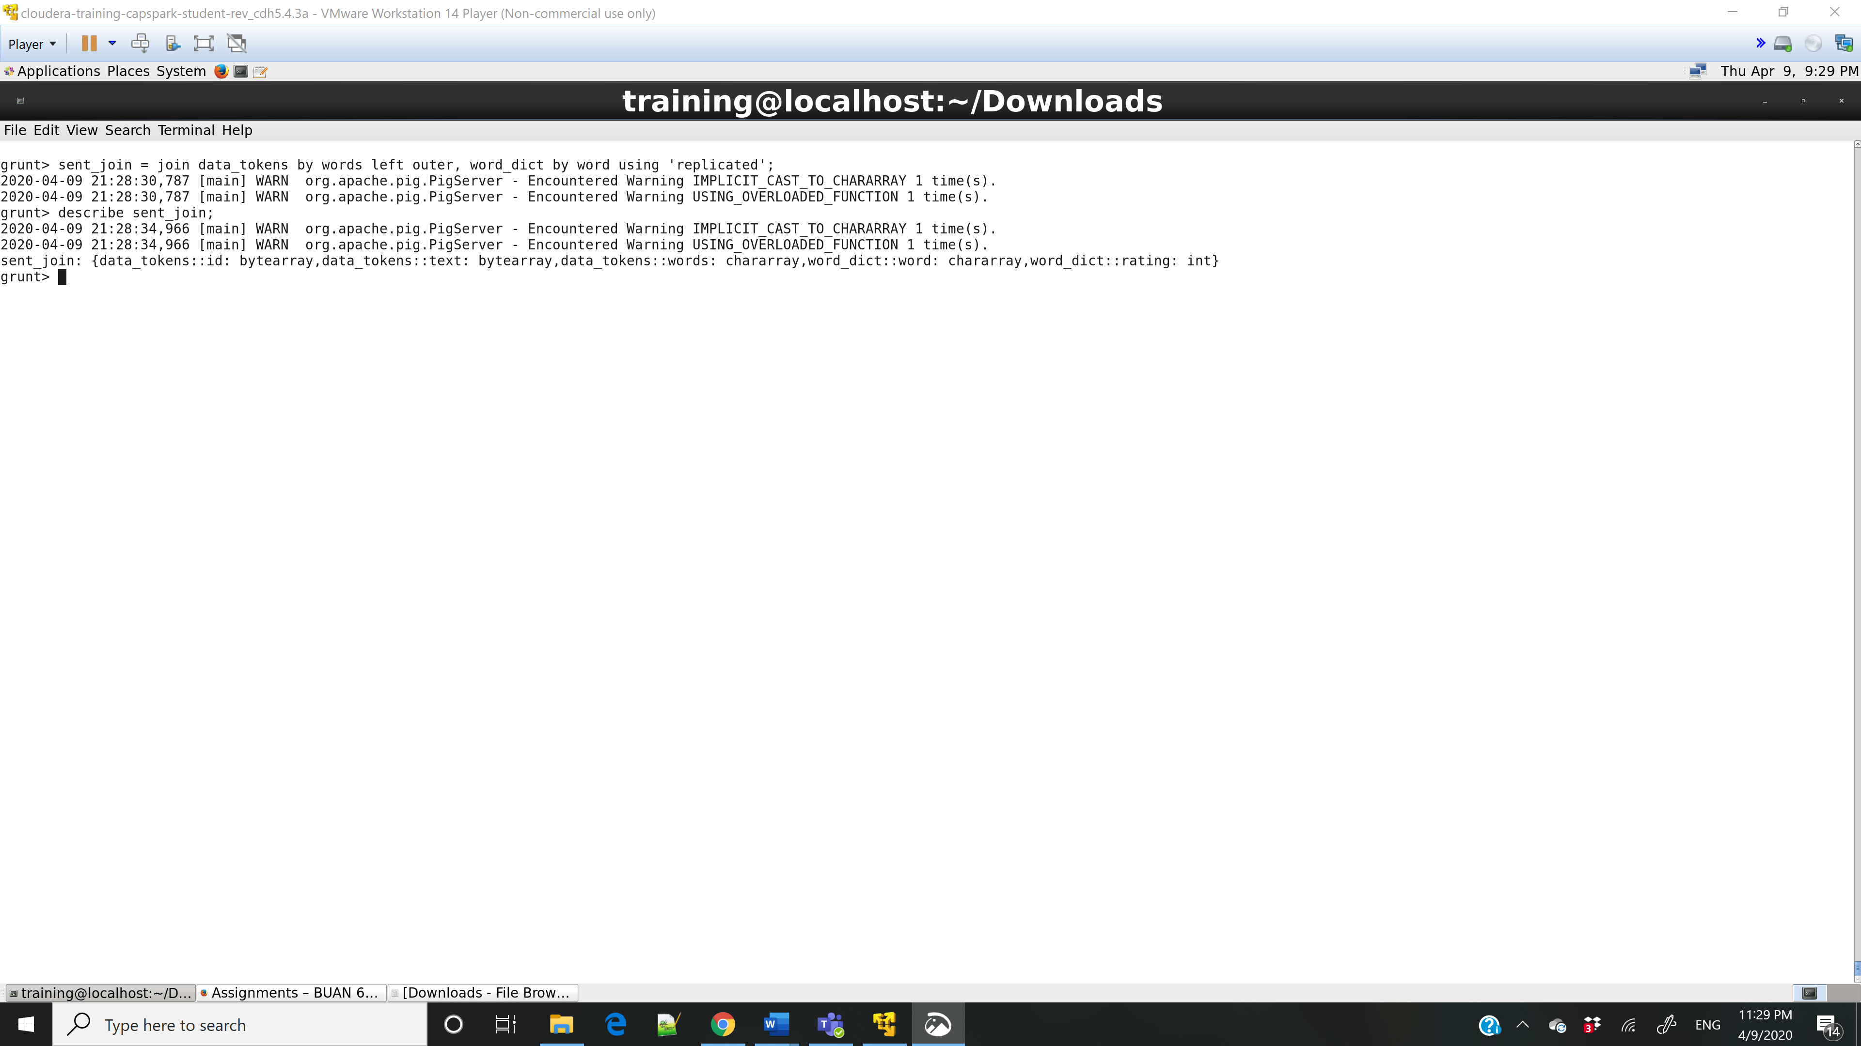

Step-13:

Q. Execute the command below, take a screenshot of the grunt shell output and paste it below.

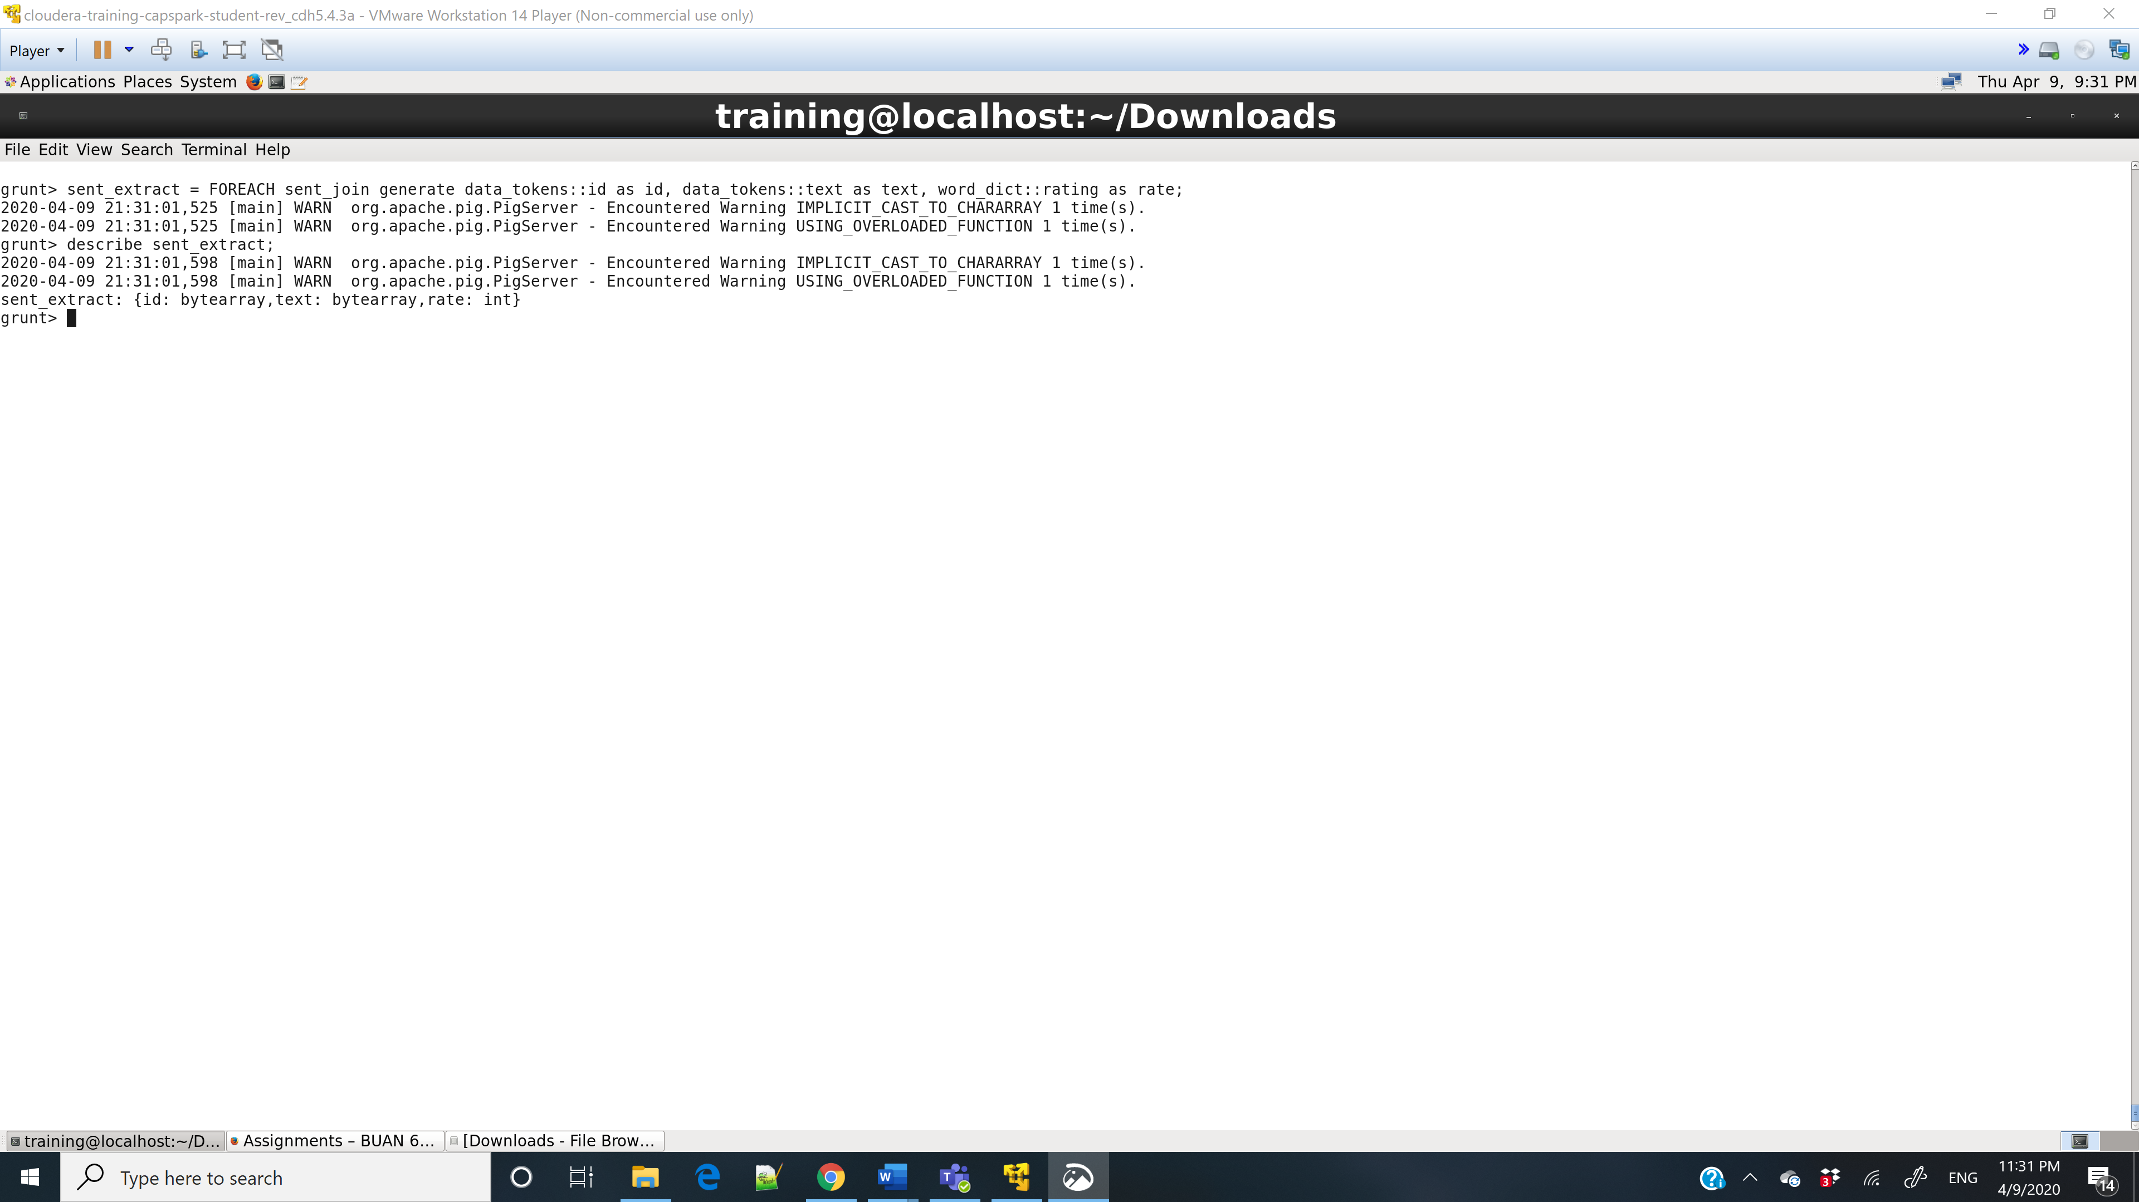

Step-14:

Q. Execute the command below, take a screenshot of the grunt shell output and paste it below.

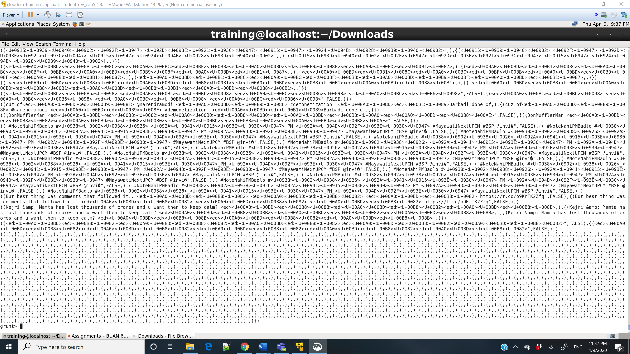

Step-15:

Q. Execute the command below, take a screenshot of the grunt shell output and paste it below.

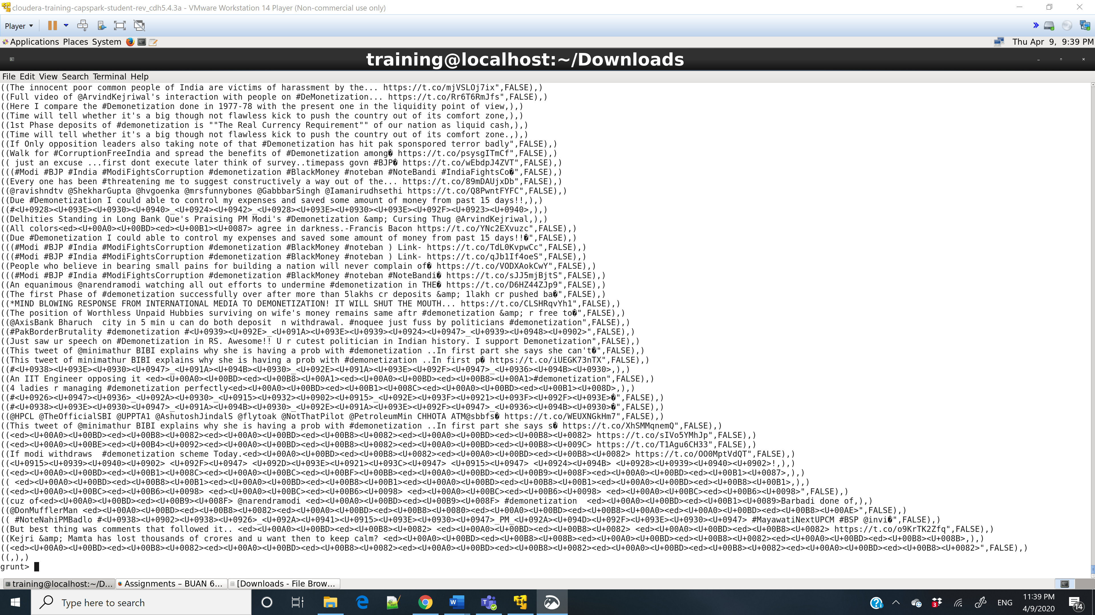

Step-16:

Q. Execute the command below, take a screenshot of the grunt shell output and paste it below.

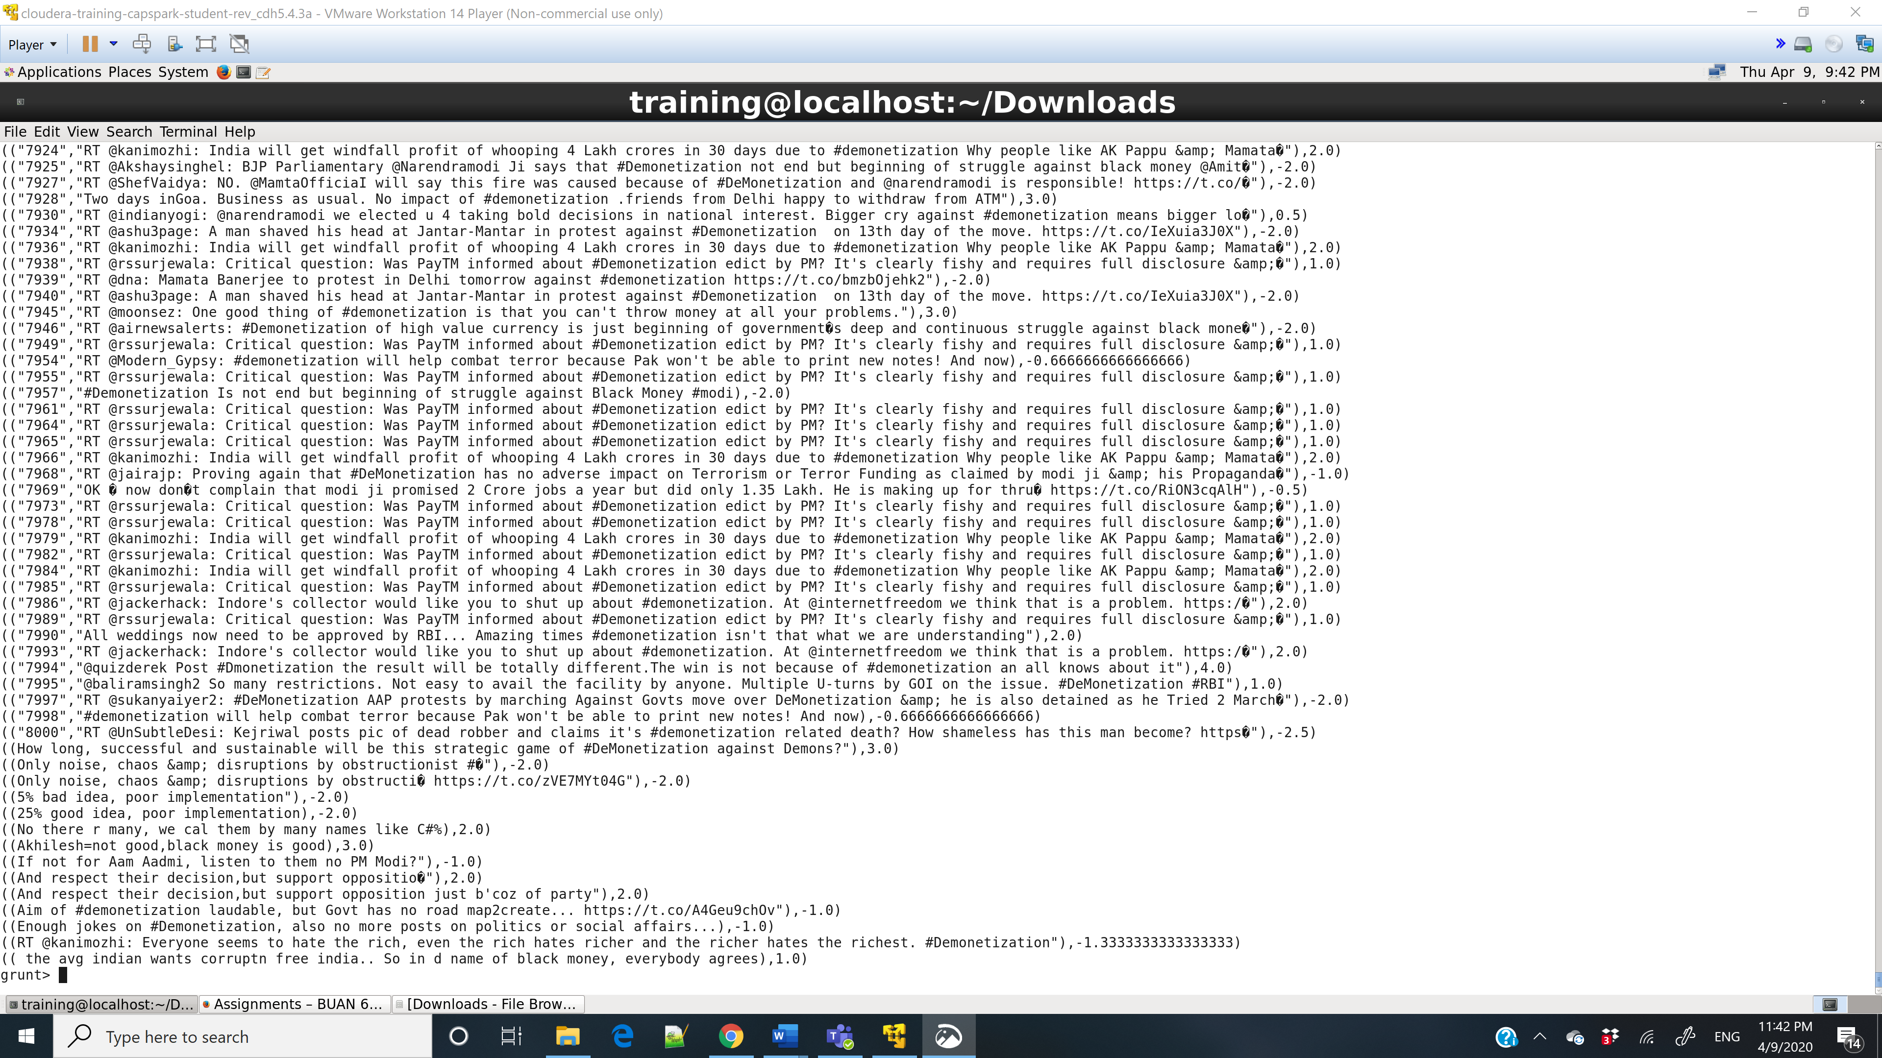

Step-17:

Q. Open HUE and go the above directory, take a screenshot of the contents of the Analyzed_Tweets file and paste it below.

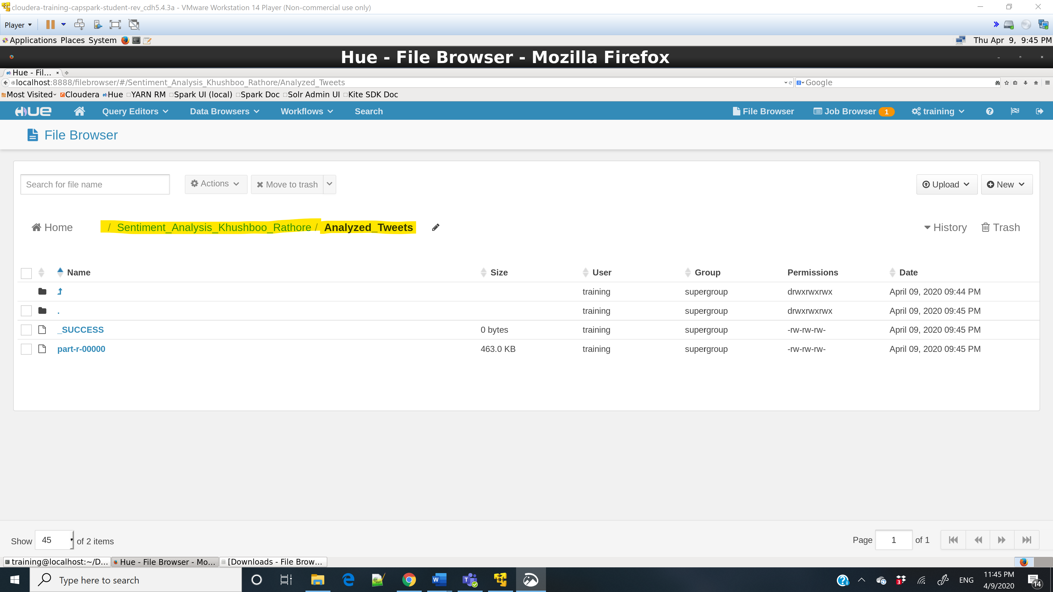

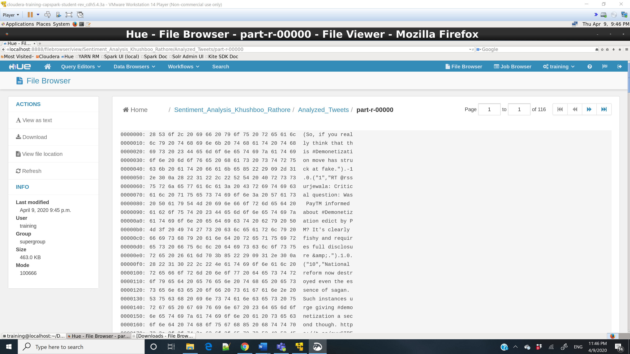

Step-18:

Q. Take a screenshot of the Beeline shell and paste it below.

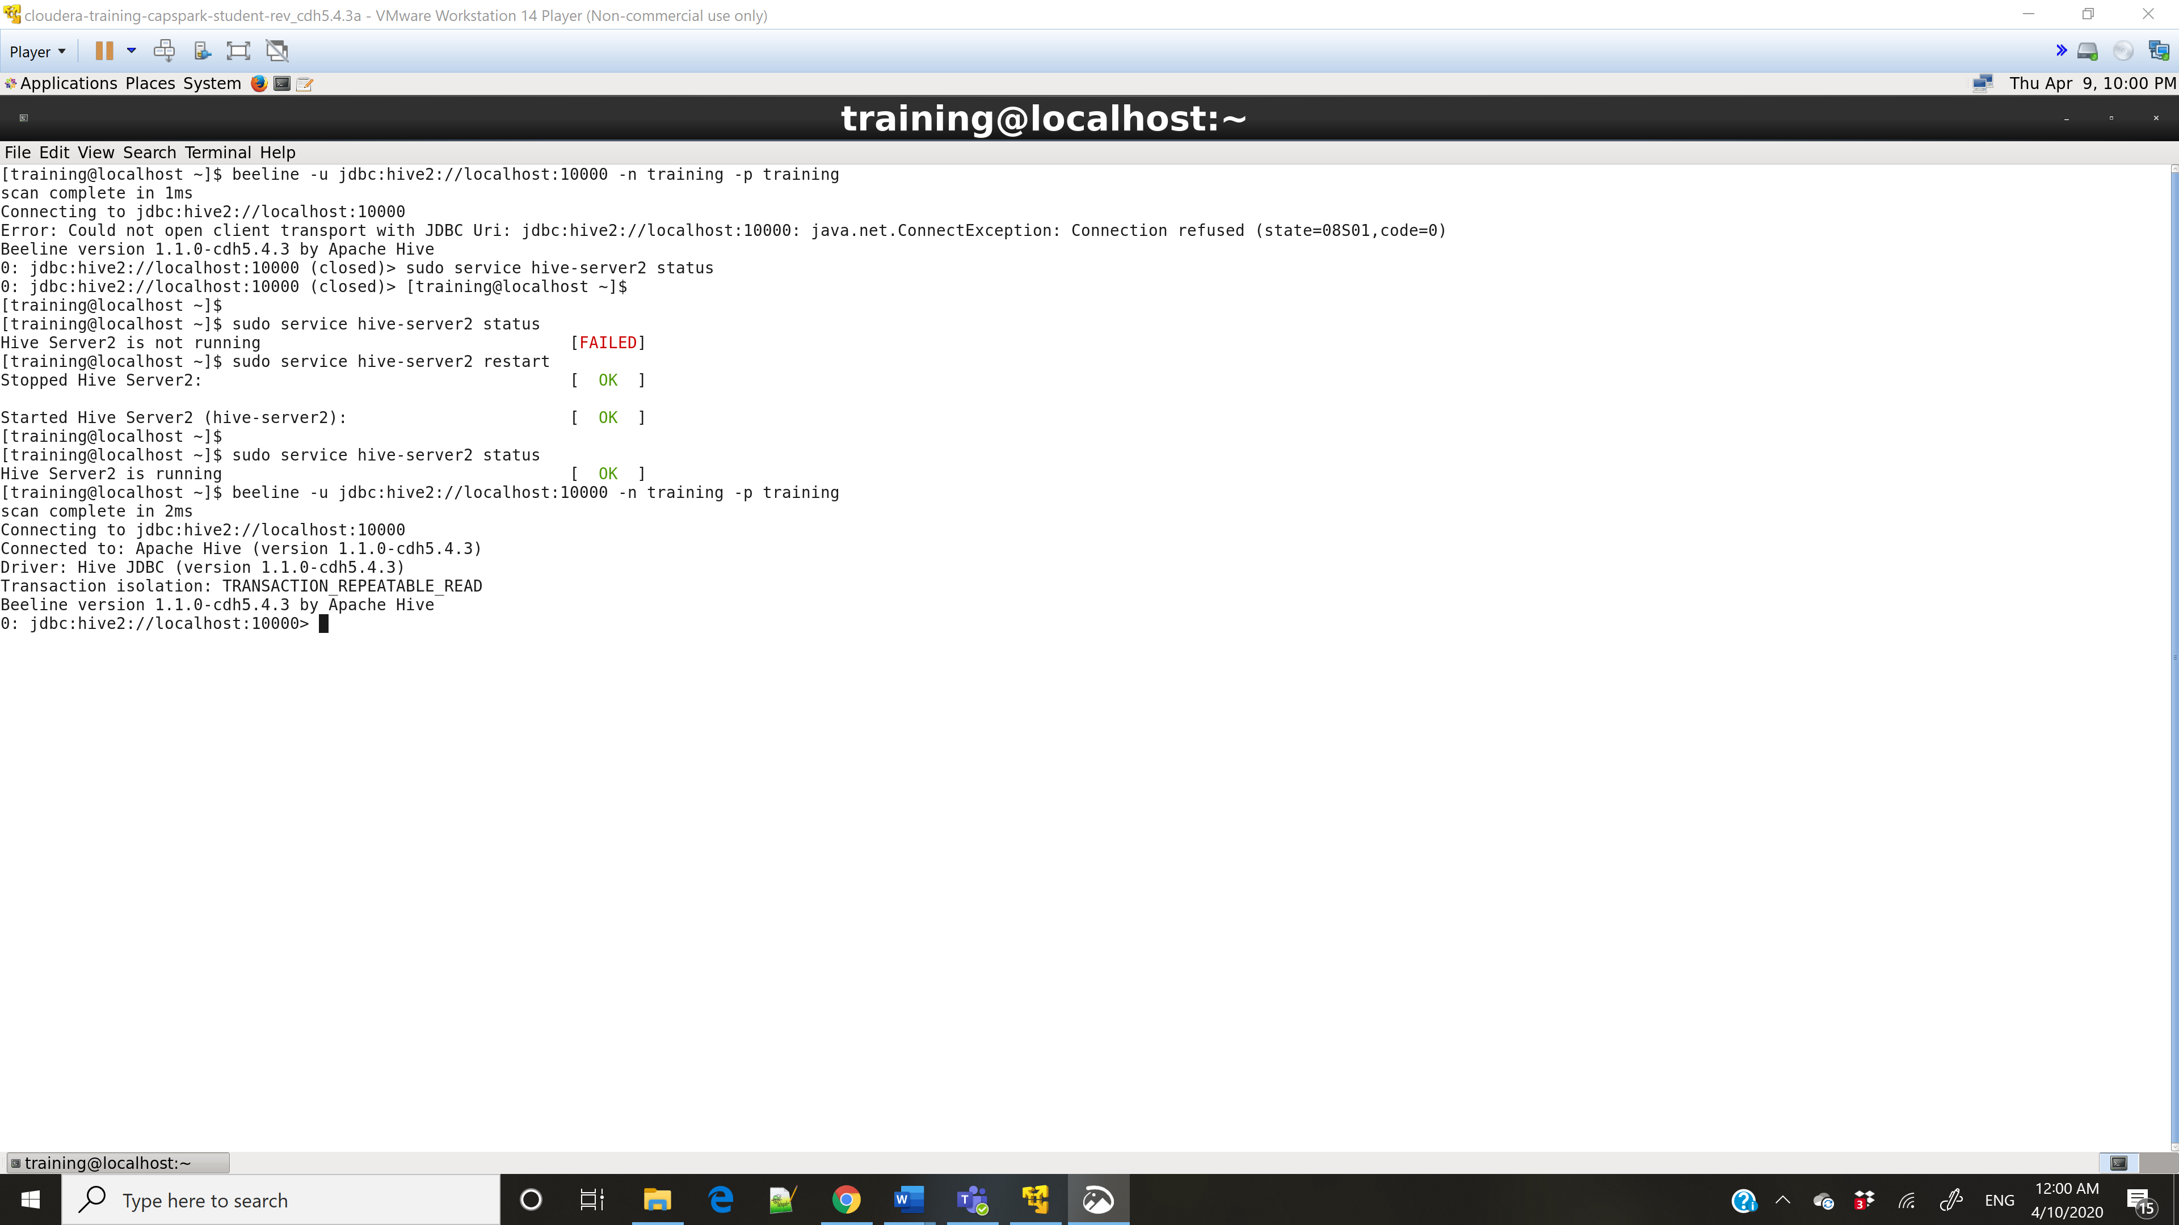

Step-19:

Q. Open the Hive Query Editor and click on the refresh button in the database panel, then click on the ‘Preview Sample Data’ button next to the tweety table. Take a screenshot of the sample data and paste it below.

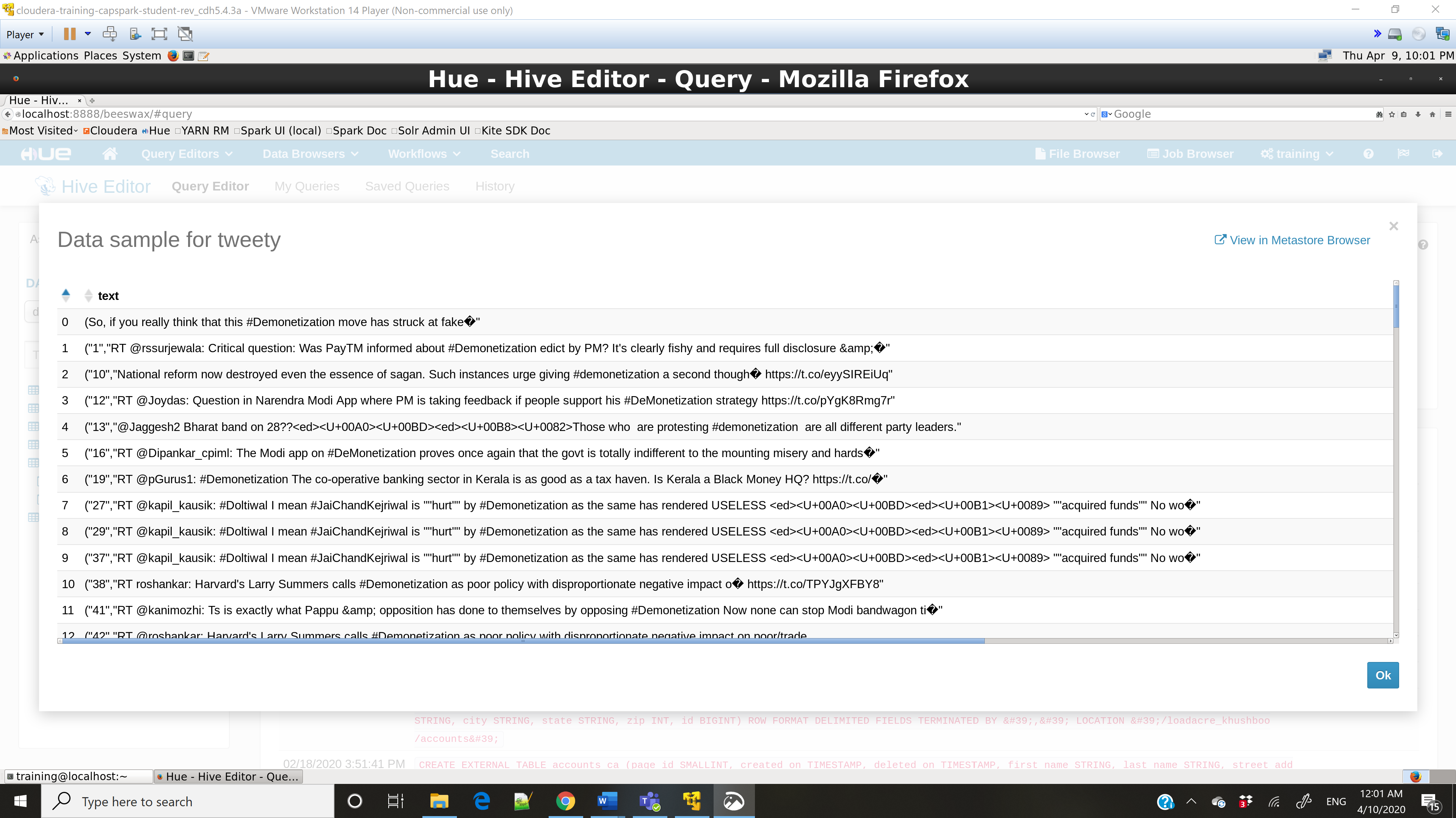

Step-20:

Q. Open Hue and view the file we just created, click on “View as text” on the left under ACTIONS. Take a screenshot of the contents and paste it below.

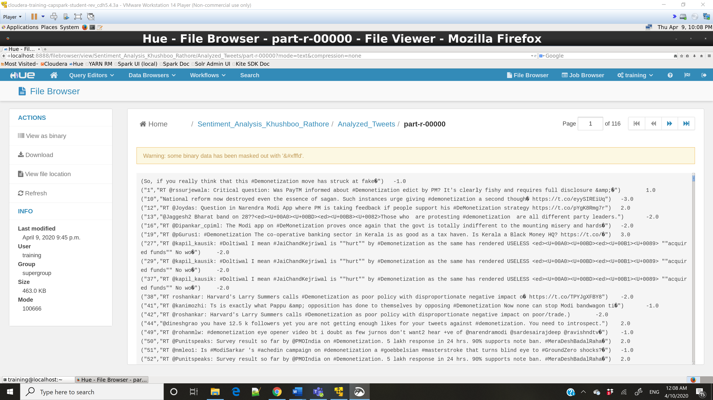

Part-3: Visualization of Sentiments:

Step-21:

Q. Execute the 2 commands below and take a screenshot of the shell output and paste it below. Highlight the file we copied from HDFS.

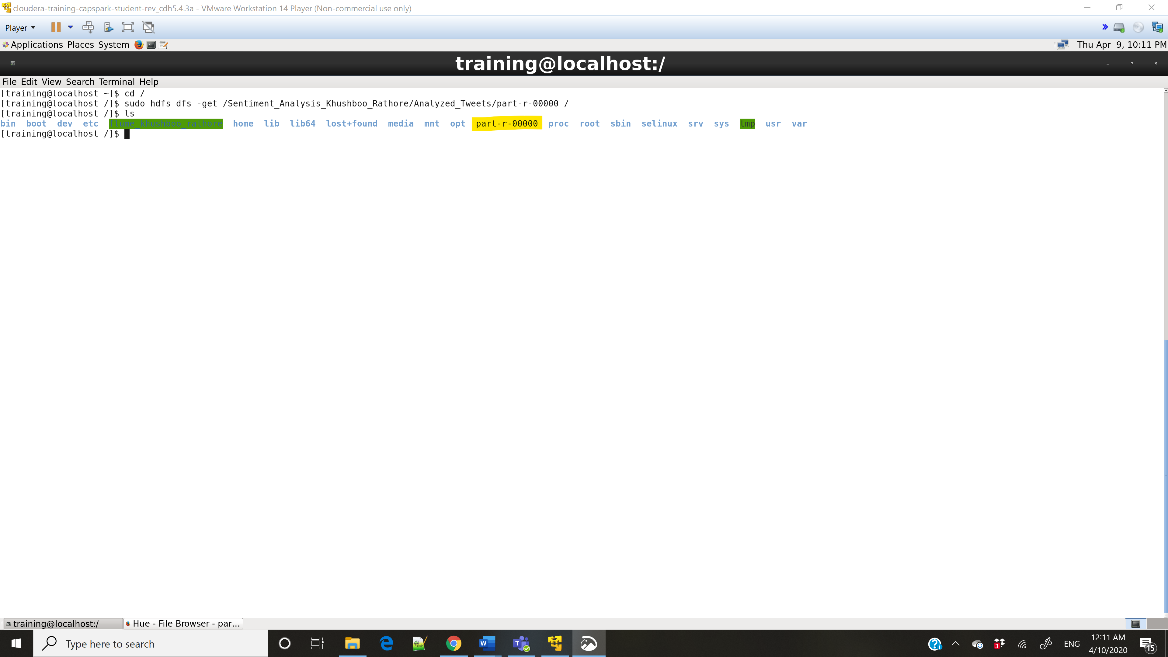

Step-22:

Q. Take a screenshot of the Jupyter Splash screen and paste it below.

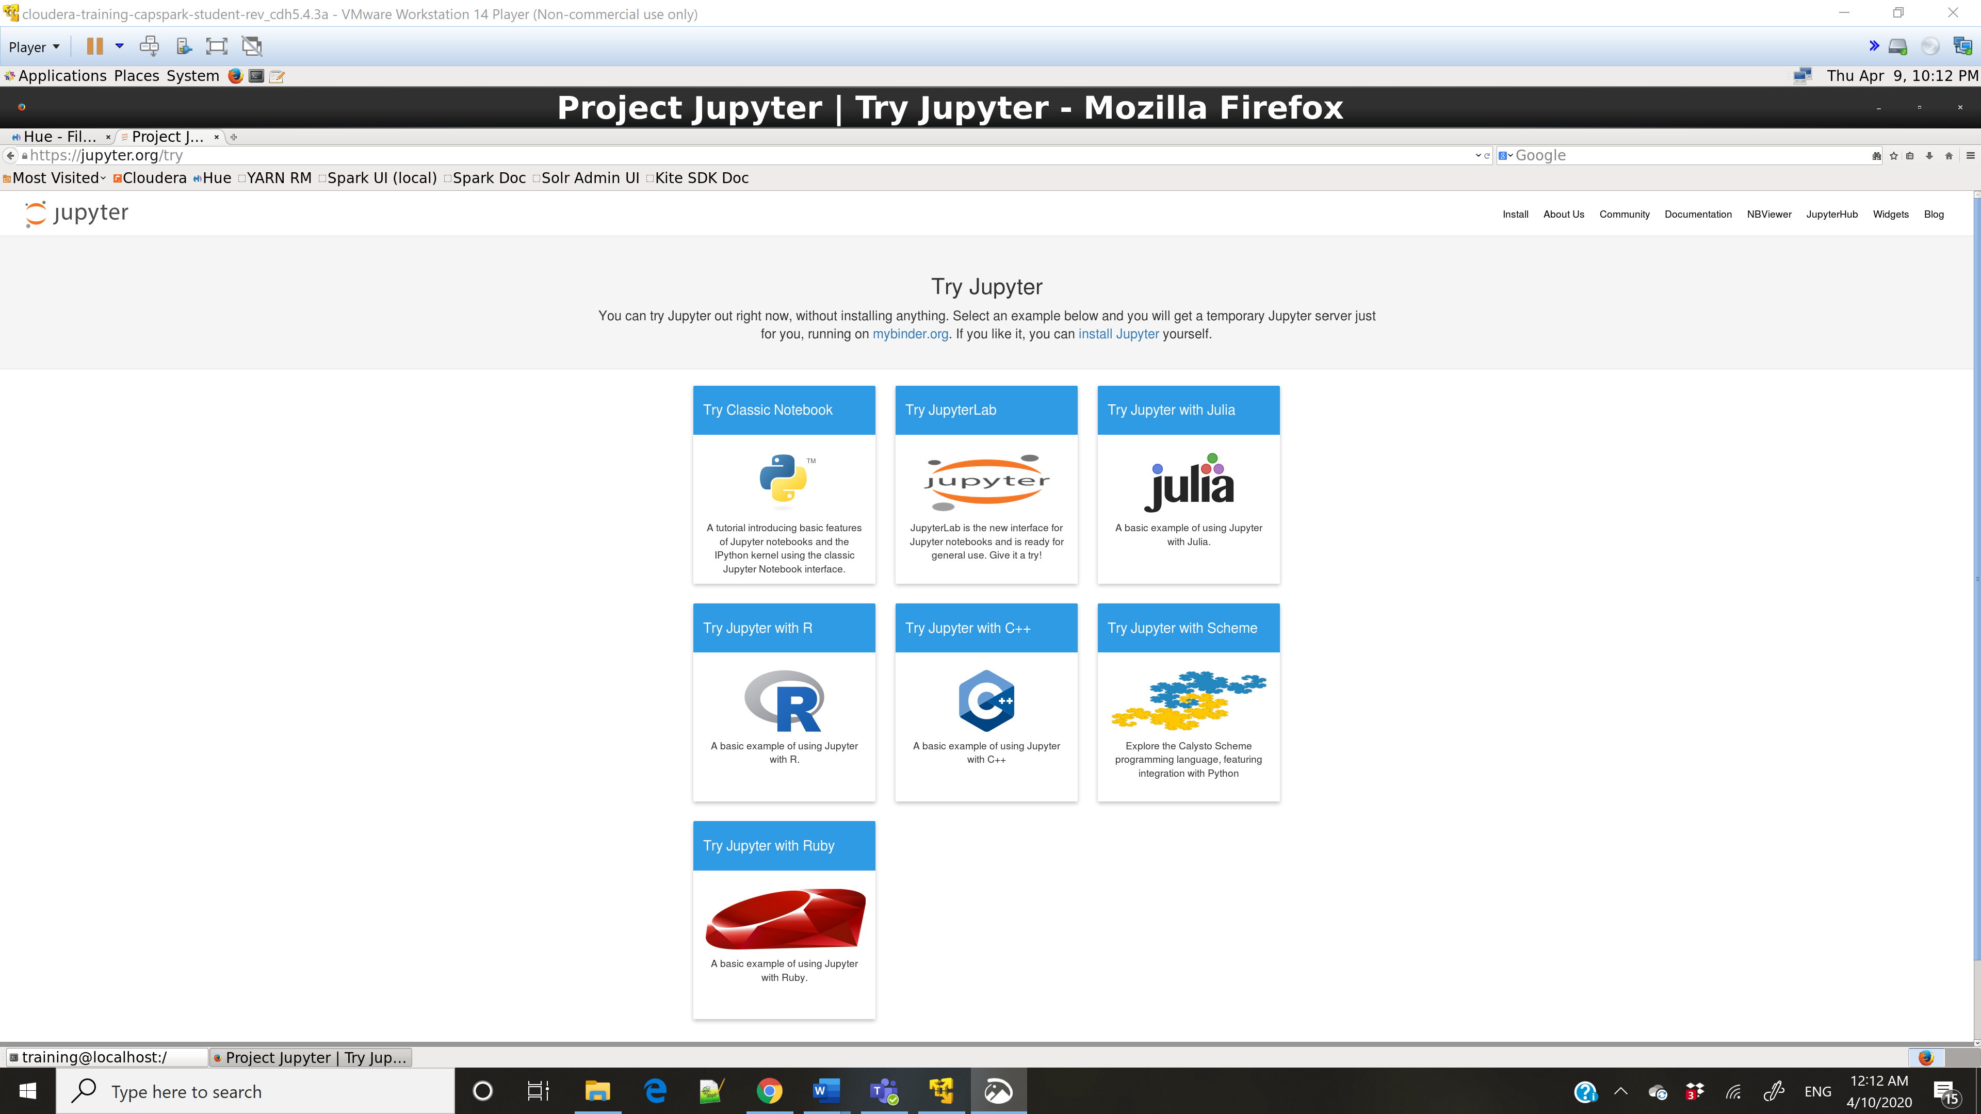

Step-23:

Q. Wait for a minute for the page to load then take a screenshot of the page you land on and paste it below.

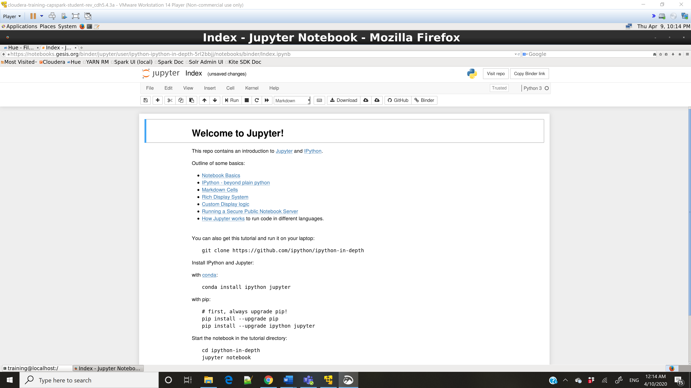

Step-24:

Q. Wait for a minute for the page to load then take a screenshot of the page you land on and paste it below.

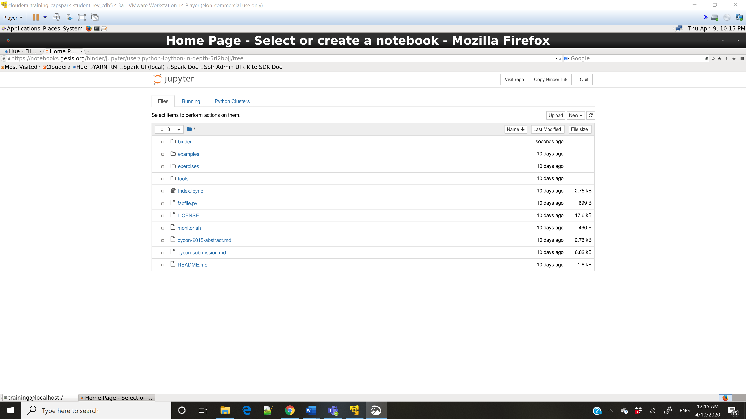

Step-25:

Q. Take a screenshot of the page you land on and paste it below.

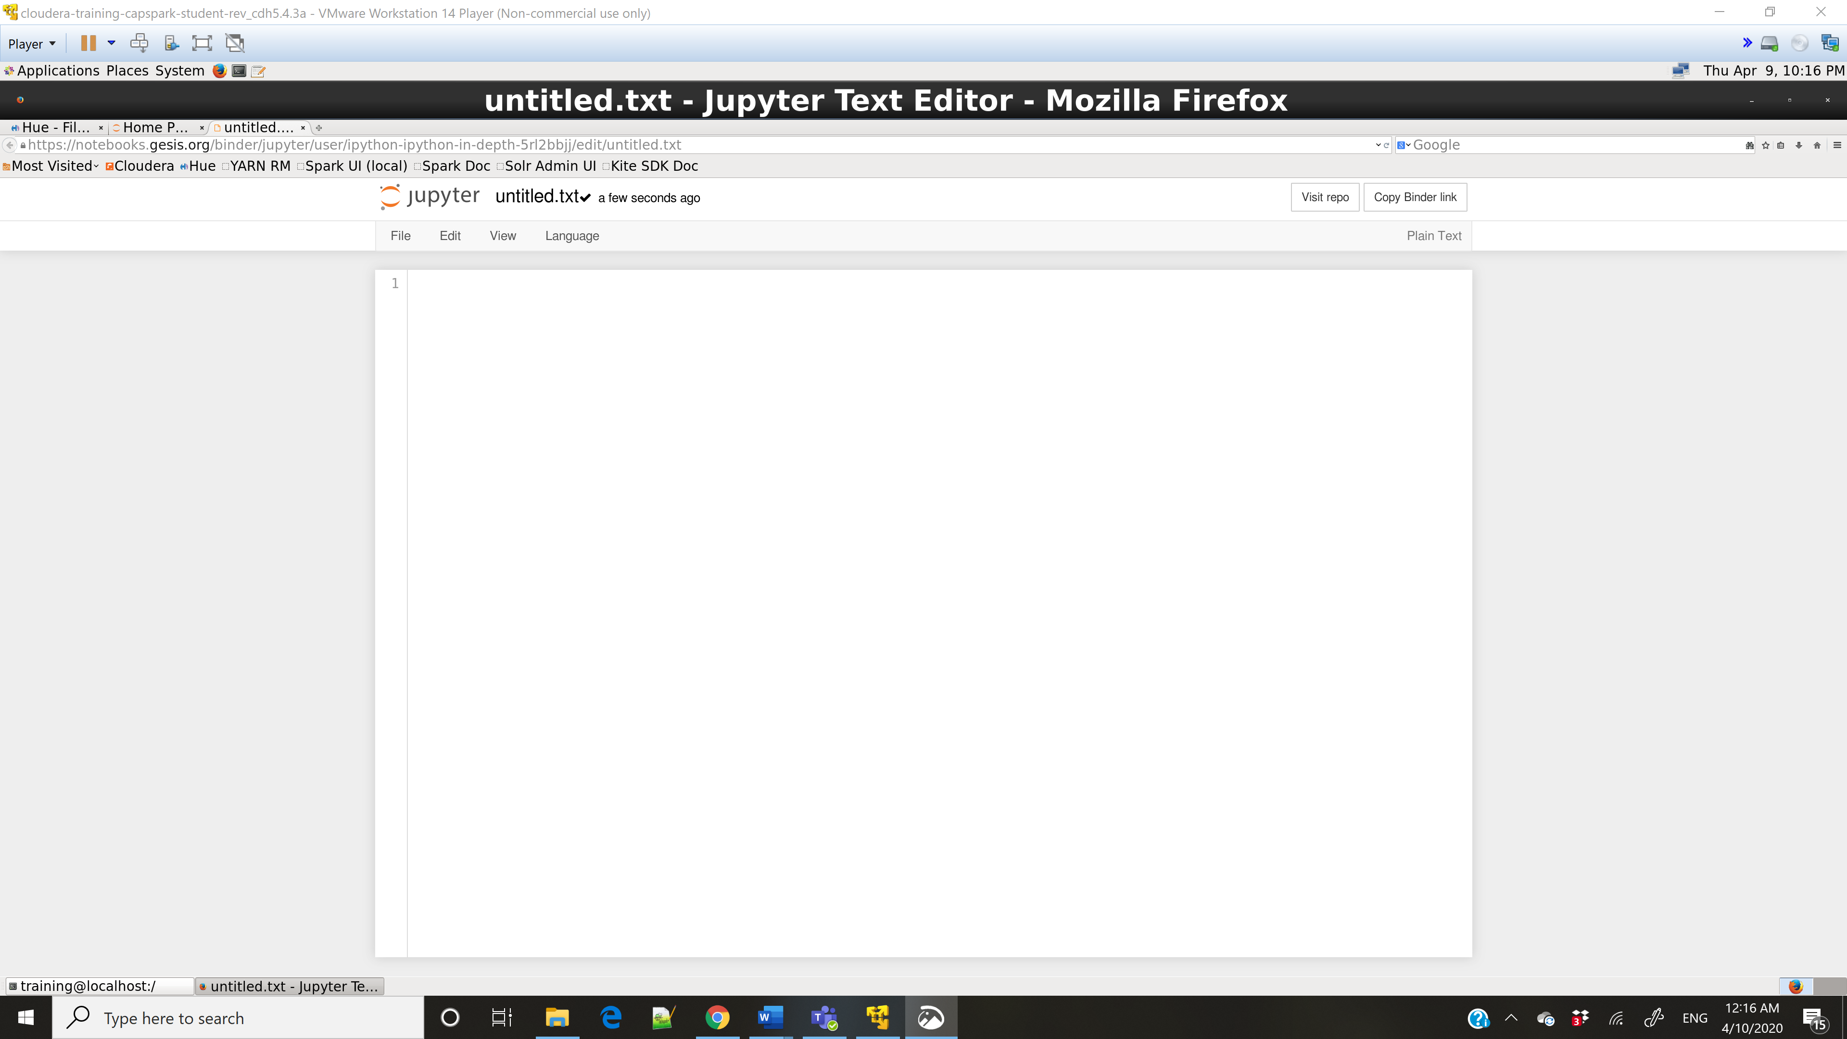

Step-26:

Q. Click on the Jupyter icon like in Step 24 and highlight the new file you just created.

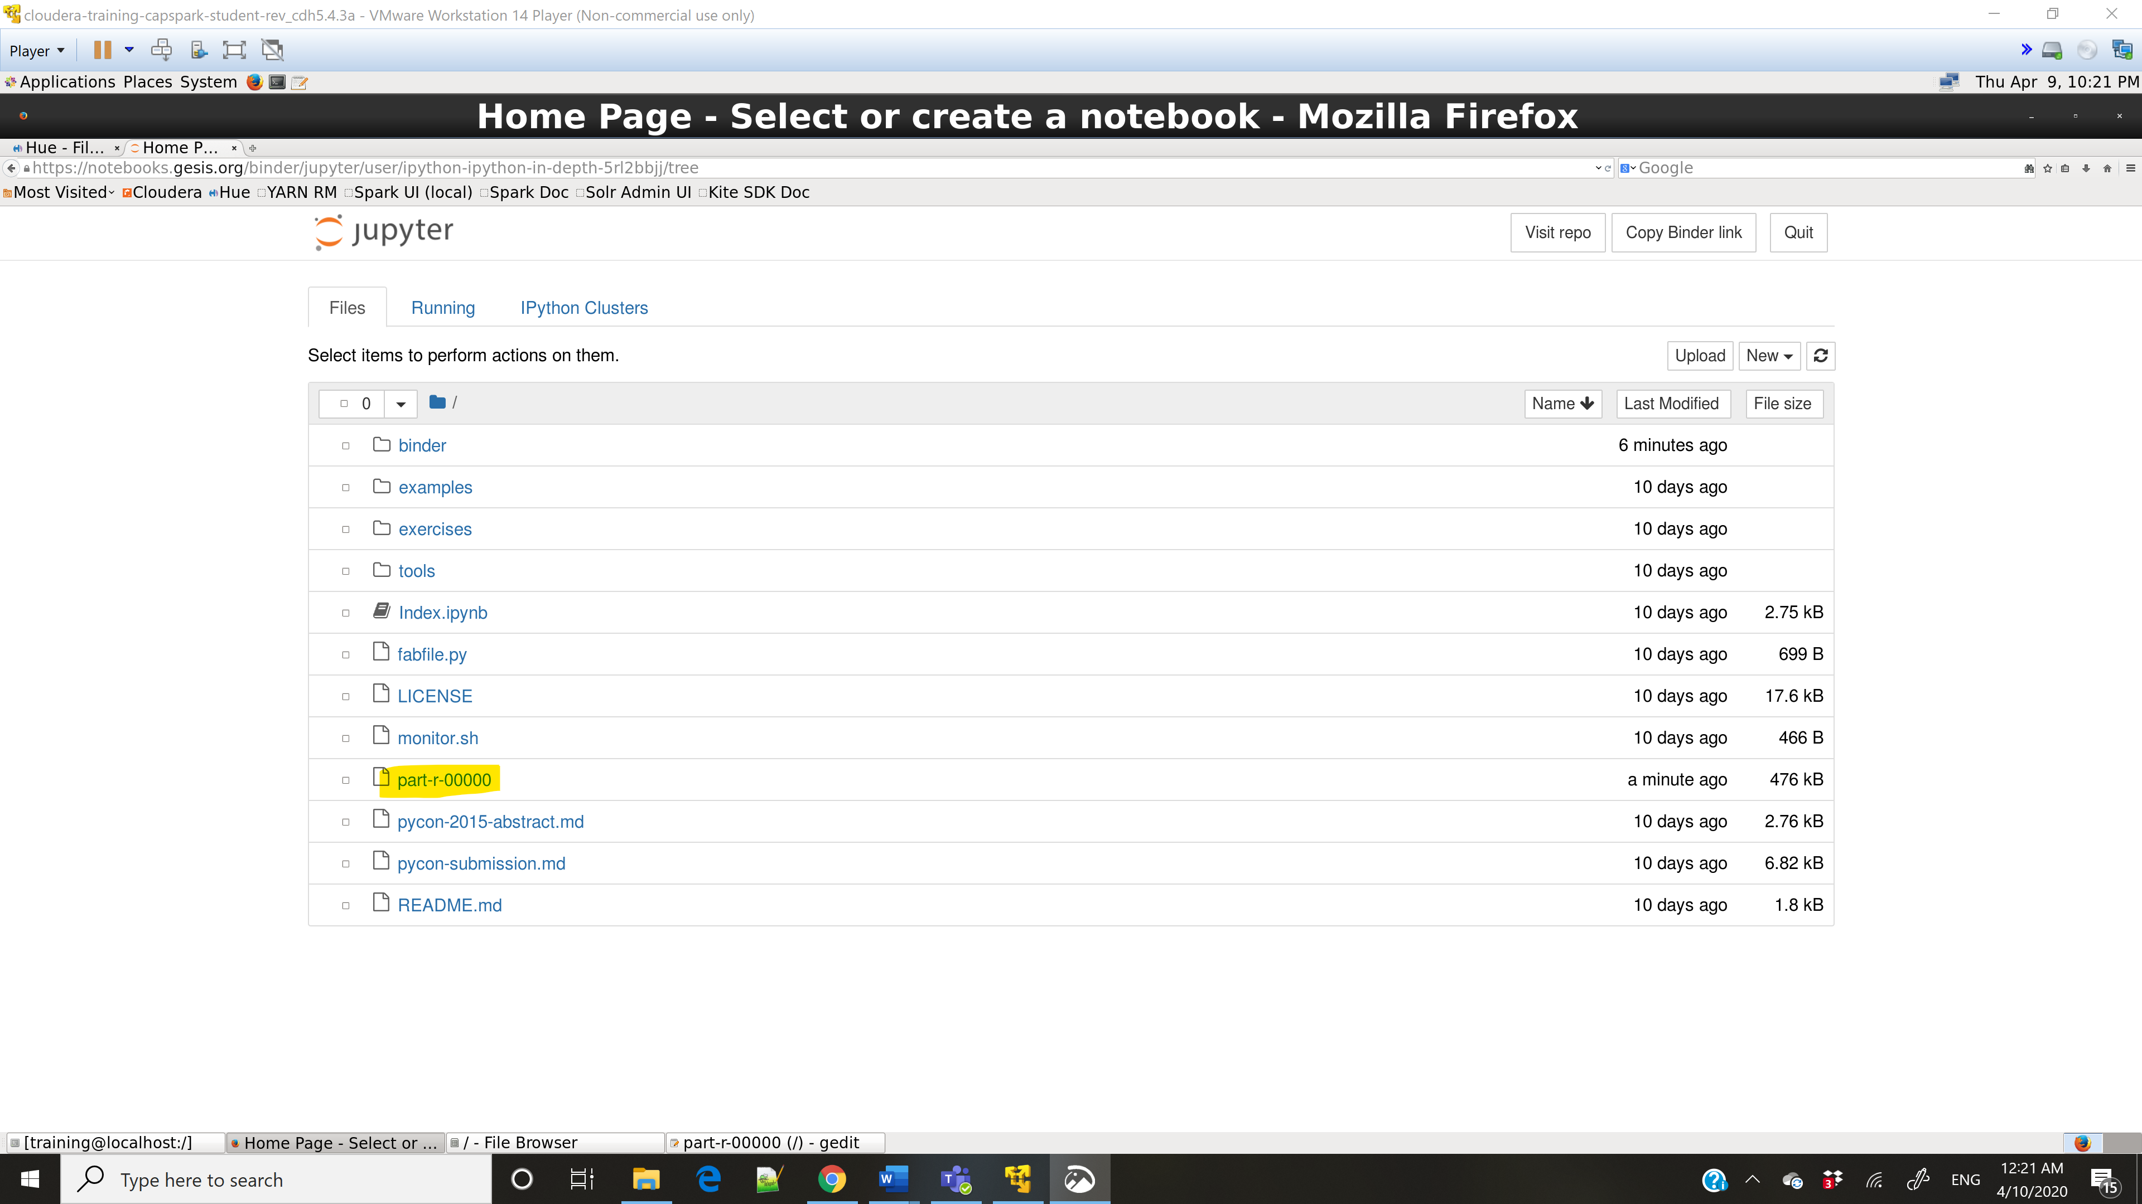

Step-27:

Q. Take a screenshot of the page you land on and paste it below.

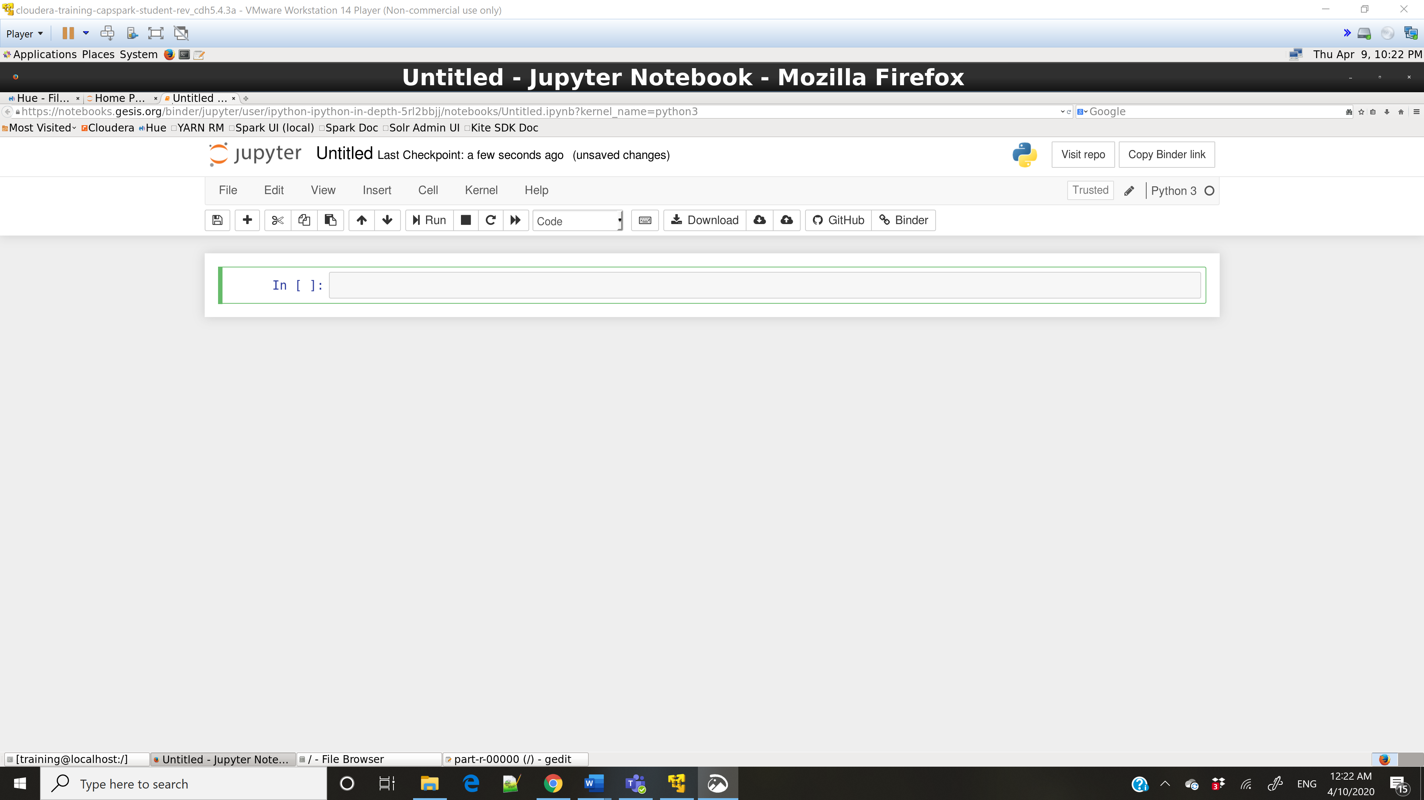

Step-28:

Q. Take a screenshot of the output and paste it below. Provide your inferences from the graph generated in this step.

The number is higher towards the positive than the negative. Hence, the sentiment is positive.

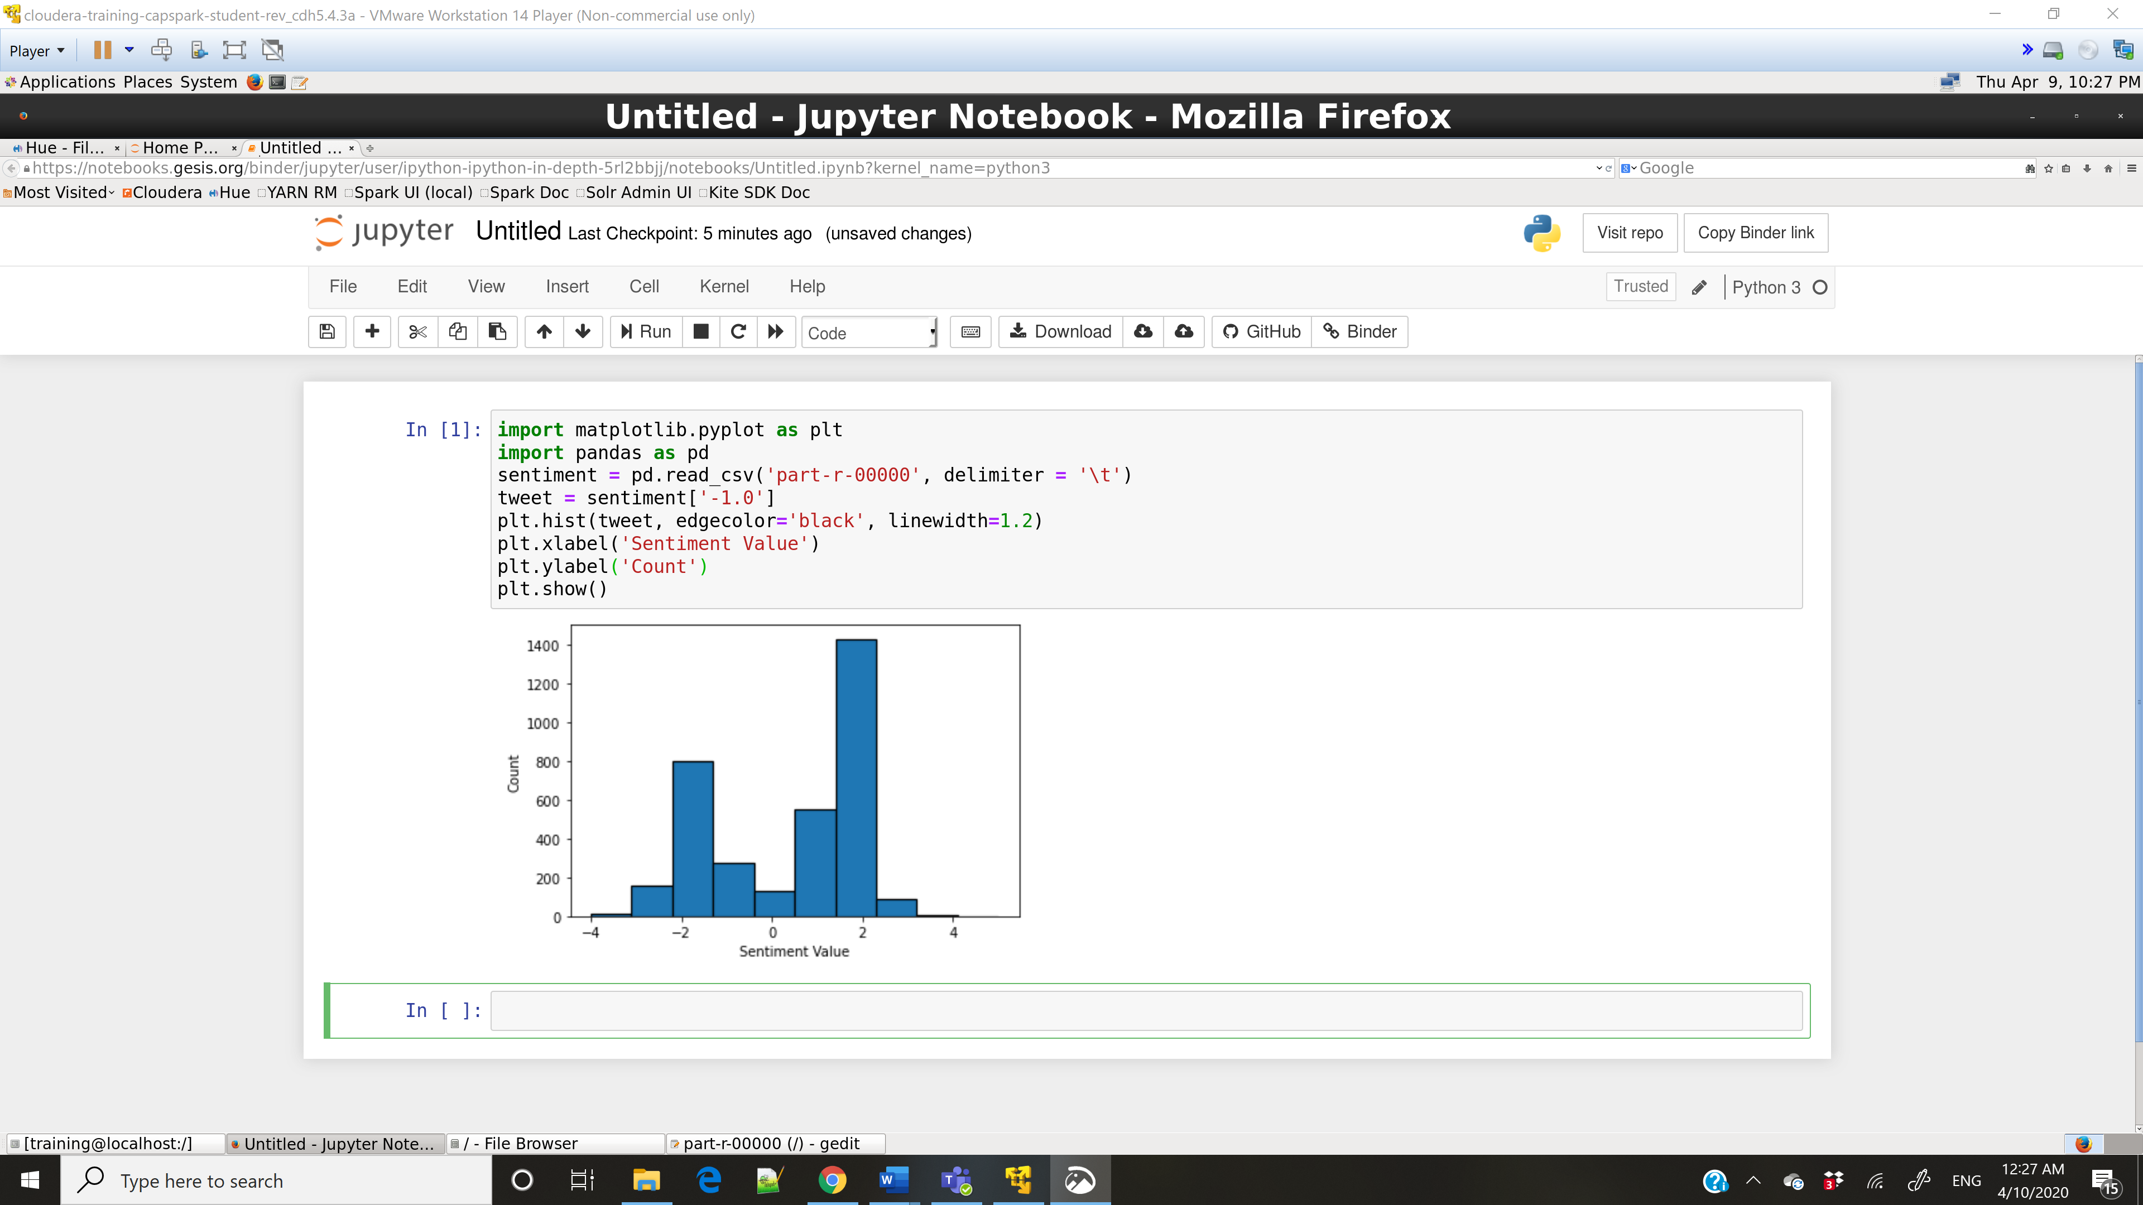

Part-4: Checksum:

Step-29:

Step-30:

Q. Now type the command and execute. Take a screenshot of the shell output, highlight the zip file and paste it below.

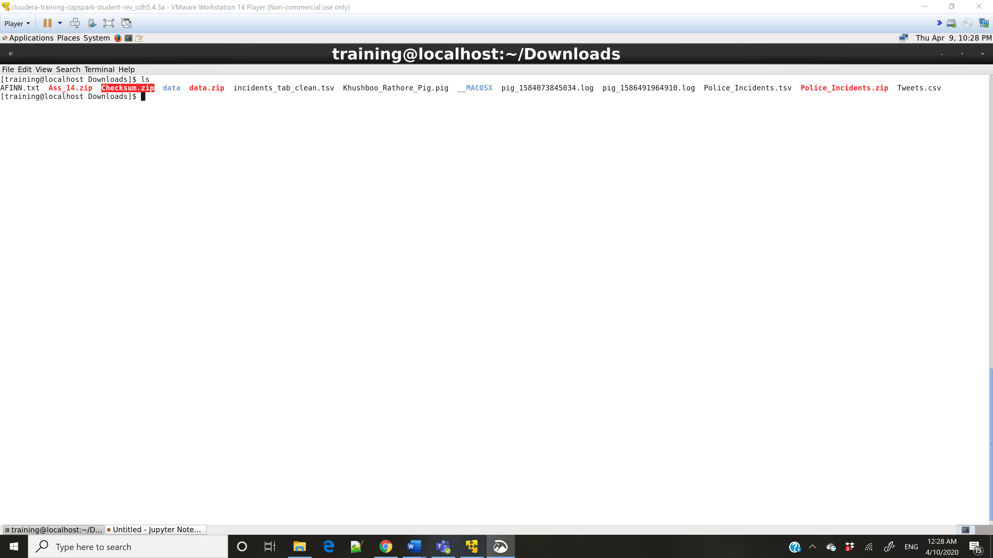

Step-31:

Q. Now type the command and execute. Take a screenshot of the shell output, highlight the contents of the zip file and paste it below.

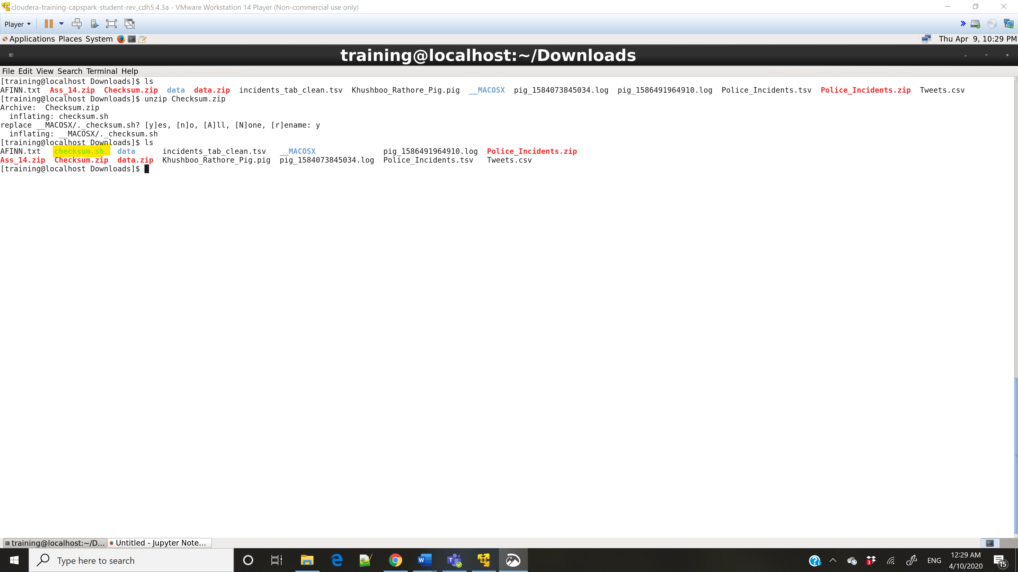

Step-32:

Q. Take a screenshot of the shell output and paste it below.

cdc6fe9e95de9702cb9262b2367129fc

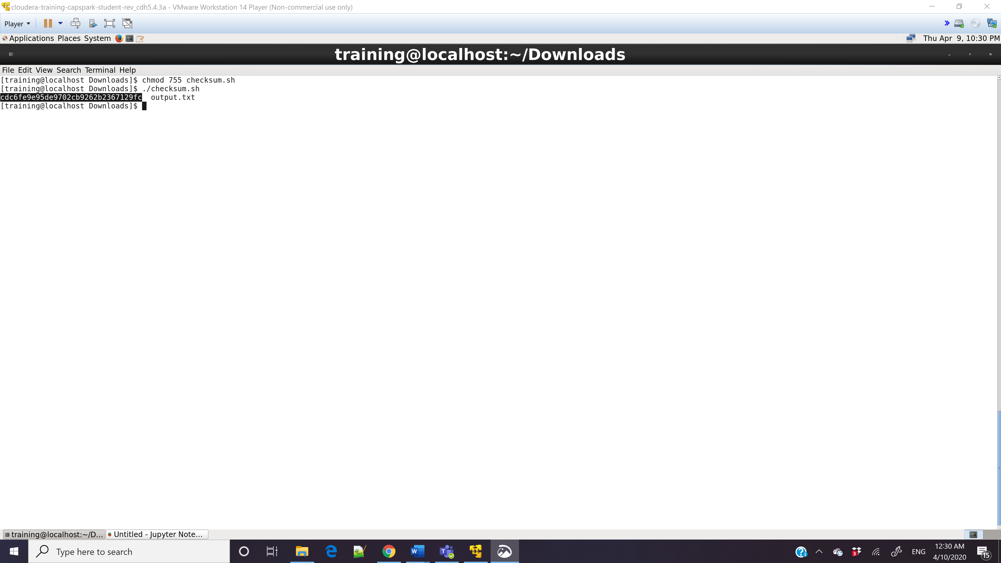

Step-33:

Q. Now type the command and execute. Take a screenshot of the shell output and paste it below.

